HANOI UNIVERSITY OF SCIENCE AND TECHNOLOGY  
SCHOOL OF ELECTRICAL & ELECTRIC ENGINEERING



**PROJECT  
GRADUATION THESIS**  
**AUTOMATIC - CONTROL**

**TOPIC**  
 **INTERNET COMMUNICATION, MANAGEMENT AND CONTROL SYSTEM DESIGN**

Supervisor’s signature

|  |  |  |
| --- | --- | --- |
| **Supervisor** | **:** | Ph. D ĐẶNG VĂN MỸ |
| **xStudents** | **:** | TRẦN VĂN NGUYÊN  NGUYỄN ĐỨC MINH |

HÀ NỘI, 8/2022

BỘ GIÁO DỤC VÀ ĐÀO TẠO  
 HANOI UNIVERSITY OF SCIENCE AND TECHNOLOGY

# **GRADUATION PROJECT DESIGN TASKS**

1. **Student Information:**

Name: Nguyễn Đức Minh – 20181905

Trần Văn Nguyên -20181911

Class: CTTT - ĐK - TĐH – HTĐ – 001 - K63

1. **Tasks to perform:**

* Analysis, selection and design of smart home models.
* Designing communication, management and control systems for smart homes via the Internet
* Model scalability with peripheral devices and systems.

1. **Required content:**

* Design models with devices capable of automatic control, interacting with each other and with remote monitoring function, ensuring security and confidentiality.
* Designing communication, management and control systems for smart homes via the Internet
* Expand connectivity with peripherals

# **WORK DISTRIBUTION**

|  |  |  |
| --- | --- | --- |
| Timeline | Students made | Work description |
| 26/04 – 01/05 | Trần Văn Nguyên | Get topic: Internet communication, management, and control system design |
| Nguyễn Đức Minh |
| 02/05 – 15/05 | Trần Văn Nguyên | Research, analyze and come up with some solutions to the topic |
| Nguyễn Đức Minh |
| 16/05 – 22/05 | Trần Văn Nguyên | * Implement the mechanical construction part * Buying components |
| Nguyễn Đức Minh |
| 23/05 – 29/05 | Trần Văn Nguyên | Complete the mechanical construction part |
| Nguyễn Đức Minh |
| 30/05 – 26/06 | Trần Văn Nguyên | * Hardware deployment * Node MCU ESP32 test function and research * Research about the sensors’ use in the system * Research about the platform to implement the application to control the system via internet |
| Nguyễn Đức Minh | * Hardware deployment * Arduino Nano test function and research * Research about the executive structure of the system (devices also) * Design schematic of the system |
| 27/06 – 03/07 | Trần Văn Nguyên | * Voltage supply analytic * Complete the hardware deployment part |
| Nguyễn Đức Minh |
| 04/07 – 17/07 | Trần Văn Nguyên | * Node MCU ESP32 programming part * Implement Blynk application |
| Nguyễn Đức Minh | * Arduino Nano programming part * Implement Blynk application |
| 18/07 - 24/07 | Trần Văn Nguyên | * Complete the design system and testing function * Complete the application * Writing report |
| Nguyễn Đức Minh |
| 25/07 – 07/08 | Trần Văn Nguyên | * Complete report * Writing powerpoint |
| Nguyễn Đức Minh |
| 08/08 – 14/07 | Trần Văn Nguyên | * Complete powerpoint |
| Nguyễn Đức Minh |

BỘ GIÁO DỤC VÀ ĐÀO TẠO  
 HANOI UNIVERSITY OF SCIENCE AND TECHNOLOGY

TEACHER'S COMMENTS

……………………………………………………………………………………  
………………………………………………………………………………………………………………………………………………………………………………………………………………………………………………………………………………………………………………………………………………………………………………………………………………………………………………………………………………………………………………………………………………………………………………………………………………………………………………………………………………………………………………………………………………………………………………………………………………………………………………………………………………………………………………………………………………………………………………………………………………………………………………………………………………………………………………………………………………………………………………………………………………………………………………………………………………………………………………………………………………………………………………………………………………………………………………………………………………………………………………………………………………………………………………………………

* INSTRUCTIONS POINTS:…………………………………………………..

…………………………………………………………………………………………..

Date......month........year 2022

Supervisor (Sign)

# **PREFACE**

The 21st century society witnessed the tremendous development of technology and marked the beginning of smart devices. Smart phones, Smart TVs are increasingly popular devices, common in people's daily lives. As the name suggests, these devices are not only capable of meeting basic human requirements, but moreover, smart devices have been born that have replaced humans in controlling and controlling functions. other functions professionally, easily and effectively.

Following the success of those smart devices, Smart home was born as a bold start to thinking about mastering technology right in people's lives. A smart home with the ability to understand human control thinking quickly becomes a fascinating technology topic.

A smart home or smart home, home automation is a type of house in which electrical and electronic equipment is installed with the effect of fully or semi-automatically, replacing humans in performing one or several management operations. , control. This electronic system communicates with the homeowner through electronic devices placed in the home, mobile phone software, tablet computers or a web interface.

At first, the idea was realized using infrared for remote control, but the distance was limited. Later, many studies aimed at improving the control distance brought many successes and practical implications such as control via telephone lines, but this is still not the optimal solution. When wireless technology developed, people thought of wireless control, remote control using a computer was born. This project presents a solution to control and monitor the house intelligently through the Internet. This solution is very possible with a precise and stable operating mechanism to create a step to develop an intelligent system applied in practice. Data and device parameters of the smart home are transmitted to the website and interface software to help ensure a secure, safe and automatic mechanism.

The topic is a highly practical product based on current technological needs, researched and manufactured based on the knowledge we have learned, inherited and promoted the results of the research works. before.

I would like to thank my family and friends for creating conditions and helping me to complete this graduation project, especially the Smart Home team.

I would like to sincerely thank the teachers in the AUTOMATIC CONTROL department for their enthusiastic guidance so that my group could complete this research topic. In addition, the guidance and suggestions of the instructor THs DANG VAN MY

Due to the limited time and knowledge, my topic will inevitably make mistakes, I hope the teachers can comment and edit it to be more complete.

Hà Nội, date......month......year 2022

Students made

# **ABSTRACT**

The main content of diploma project is to present IoT related issues. It’s Smart Home model, IoT’s application in building a real Smart Home.

The issues are presented in six chapters:

Chapter 1: Smart Home overview

Chapter 2: Overview design of smart home control system

Chapter 3: Microprocessor block

Chapter 4: Design system actuators structure for smart home

Chapter 5: Electronic components, design monitoring and alarm systems for smart home

Chapter 6: Smart home control and monitoring system

Chapter 7: Design and production of experimental models

Chapter 8: Conclusion

**TABLE OF CONTENTS**

GRADUATION PROJECT DESIGN TASKS 2

WORK DISTRIBUTION 3

PREFACE 7

ABSTRACT 9

CHAPTER 1: SMART HOME OVERVIEW 19

1. Smart home overview 19

1.1. Context and demand for smart home use 19

1.2. Smart home models are being applied today 21

**1.2.1.** **Smart home solutions in the world** 21

**1.2.2.** **Smart home solutions in Vietnam** 22

2. Select design direction 23

CHAPTER 2: OVERVIEW DESIGN OF SMART HOME CONTROL SYSTEM 26

1. Structural diagram of the house and function 26

1.1 Structural Diagram 26

1.2 Function 26

2. Working principal diagram 27

2.1 Electronic system 27

2.2 System circuit diagram 29

CHAPTER 3: MICROPROCESSORS – CONTROL BLOCK 30

1. Specification 30

2. Introduction of Arduino Nano 30

2.1 General structure 30

2.2 Source block 31

2.3 Memory 31

2.4 Specifications 32

3. Node MCU ESP32 33

3.1. What is ESP32 33

3.2. Specifications of ESP32 34

3.3. Different Ways to Program 35

3.4. ESP32 DevKit – The ESP32 Development Board 35

3.5. Layout 36

3.6. Pinout of ESP32 Board 37

3.7. Conclusion 37

CHAPTER 4: DESIGN SYSTEM ACTUATORS SYSTEM STRUCTURE FOR SMART HOME 38

1. Specification 38

2. Overview of the devices used in the actuator system 38

2.1 Servo motor SG90 38

2.2 5.6V/2.1A DC stepper motor and A4988 control module 39

2.3 MG996 RC Servo Motor 41

2.4 Stepper motor Size 42 17HS8401 42

4. Device modules used in model and function 43

4.1. Garden and periphery 43

4.2. Living room 45

4.3. Parking garage 48

4.4. Sleeping room 48

4.5. Entertainment/movie room 50

4.6. Kitchen 52

CHAPTER 5: ELECTRONIC COMPONENTS, DESIGN MONITORING AND ALARM SYSTEM FOR SMART HOME 54

1. Specification 54

2. Electric components and overview of sensors used in monitoring and warning systems 54

2.1 Temperature and humidity sensor DHT11 54

2.2 Gas sensor MQ2 56

2.3 Motion sensor HC-SR510 58

2.4 IR Infrared Obstacle Avoidance Sensor Module 60

2.5 Light Sensor 61

2.6 Rain sensor 63

2.7 Peltier Cooling Module 64

2.8 Module Relay 12V DC 66

2.9 Radiator fan 68

2.10 LCD 16x2 69

2.11 I2C Communication 71

2.12 Keypad 3x4 75

2.13 Button 76

2.14 Voltage Supply 76

2.15 IC 74HC595 78

2.16 Other components 81

3. Working principle of monitoring systems 81

3.1. Algorithm flowchart 81

3.2. Fire alarm system works based on temperature sensor DHT11 82

3.3. Gas leak alarm system 83

3.4. Intrusion warning system 83

CHAPTER 6: SMART HOME CONTROL AND MONITORING SYSTEM 84

1. Learn about Wi-Fi and how it works. 84

1.1. What is Wi-Fi? 84

1.2. Working principles of Wi-Fi 84

1.3. How does Wi-Fi work? 84

2. IP Address 85

3. Blynk Application 85

4. Software 86

5. Design of monitoring and control system via internet 93

6. Principle of data transmission control: 94

7. Principle analysis in controlling a specific mechanism: 95

CHAPTER 7: DESIGN AND PRODUCTION OF EXPERIMENTAL MODELS 96

1. Results achieved 96

2. Monitoring and control interface 97

3. Comment 98

CHAPTER 8: CONCLUSION 100

1. Conclusion 100

2. Future work 100

References 102

**TABLE OF FIGURES**

Figure 1. 1 General model of smart home. 20

Figure 1. 2 World Smarthome market growth chart 20

Figure 1. 3 Smart home market growth chart only for North America market 21

Figure 1. 4 Smart home model of Compro Technology company. 21

Figure 1. 5 Smart home model of the company IEI Integration 22

Figure 1. 6 Smart home model Eco-Future-World 22

Figure 1. 7 Smart home model of BKAV 23

Figure 1. 8 Smart home model of Lumi 23

Figure 1. 9 Development trend of smarthome 24

Figure 2. 1 Structural diagram of smart house 25

Figure 2. 2 Functions to use 26

Figure 2. 3 The schematic diagram of the working principle of the electronic system 26

Figure 2. 4 System circuit diagram. 28

Figure 3. 2 Hardware Architecture of Arduino Nano 29

Figure 3. 3 ESP32 Architecture 32

Figure 3. 4 ESP32 DevKit Board 34

Figure 3. 5 ESP32 Chip Module Board 34

Figure 3. 6 ESP32 Layout 35

Figure 3. 7 ESP32 pinout 36

Figure 4. 1 Servo motor S90 37

Figure 4. 2 Servo motor S90 pinout 37

Figure 4. 3 A4988 module 38

Figure 4. 4 A4988 module pinout 38

Figure 4. 5 Circuit diagram of stepper DC and A4988 39

Figure 4. 6 MG996 RC Servo Motor Pinout 40

Figure 4. 7 Stepper motor 17HS8401 41

Figure 4. 8 Flowchart of garden and periphery system 42

Figure 4. 9 Flowchart of the password system 43

Figure 4. 10 Flowchart of the living room 45

Figure 4. 12 Flowchart of the bedroom 47

Figure 4. 13 Flowchart of the entertainment room 49

Figure 4. 14 Flowchart of the kitchen 51

Figure 5. 1 DHT11 sensor pinout 52

Figure 5. 2 MQ2 gas sensor module 54

Figure 5. 3 Structure of the MQ2 gas sensor module 55

Figure 5. 4 Motion sensor module HC-SR510 57

Figure 5. 5 HC-SR510 motion sensor input 57

Figure 5. 7 Diagram of IR Infrared Obstacle Avoidance Sensor Module 59

Figure 5. 8 Light sensor pinout 60

Figure 5. 9 Light sensor principle diagram 1 60

Figure 5. 10 Light sensor principle diagram 2 61

Figure 5. 11 Rain sensor 62

Figure 5. 12 Peltier cooling module 63

Figure 5. 13 Peltier cooling module configuration 63

Figure 5. 14 Module Relay 12V DC 2 channels 64

Figure 5. 15 Module Relay 12V DC 1 channel 65

Figure 5. 16 Module Relay 12V DC working principle 1 65

Figure 5. 17 Module Relay 12V DC working principle 2 66

Figure 5. 18 Radiator fan 66

Figure 5. 19 LCD 16x2 67

Figure 5. 20 LCD 16x2 pinout 68

Figure 5. 21 I2C structure 70

Figure 5. 22 I2C transmission frame 70

Figure 5. 23 I2C address bit block 71

Figure 5. 24 I2C address bit block 72

Figure 5. 25 I2C module 73

Figure 5. 26 Keyboard 3x4 73

Figure 5. 27 Button working principle 74

Figure 5. 28 Button 74

Figure 5. 29 Adapter 12V – 5A 75

Figure 5. 30 Adapter 12V – 5A 76

Figure 5. 31 Non-Isolation Voltage Supply 76

Figure 5. 32 74HC595 pinout diagram 77

Figure 5. 33 74HC595 shift register working principle 78

Figure 5. 34 Algorithm flowchart of monitoring systems 80

Figure 6. 1 Interface of the Arduino software 84

Figure 6. 2 Arduino Setup Preferences 85

Figure 6. 3 Arduino boards manager 85

Figure 6. 4 Arduino setup ESP32 librabry 85

Figure 6. 5 Create Blynk project 86

Figure 6. 6 Create Blynk project 87

Figure 6. 7 Blynk hardware configuration 2 87

Figure 6. 8 Blynk widget configuration 88

Figure 6. 9 Blynk switch configuration 88

Figure 6. 10 Blynk interface 1 89

Figure 6. 11 Blynk interface 2 91

**TABLE OF TABLES**

Table 4. 1 MG996 RC Servo Motor pinout description 40

Table 4. 2 Stepper motor 17HS8401 specification 41

Table 5. 1 DHT11 pinout description 53

# **CHAPTER 1: SMART HOME OVERVIEW**

## **Smart home overview**

### **Context and demand for smart home use**

Today, as the standard of living is improving, people's needs require the best comforts and support. Along with that, the continuous expansion of the internet network across countries and territories makes monitoring and controlling the system via the internet a necessity. From those actual requirements and conditions, the idea of ​​a smart home was formed, where all human activities are supported and helped flexibly, in addition, the house can also be self-contained. management in the most intelligent way.

So, what is a smart home?

The intelligence of a house is shown in four aspects as follows:

* The first is automation. The house is equipped with a system of sensors such as temperature sensor, humidity sensor, gas sensor, fire alarm sensor, obstacle sensor, light sensor ... with the ability to automatically operate according to environmental conditions. Smart homes help us monitor electricity and water consumption better than usual.
* Second, is the ability to satisfy user needs. The owner of the house can control it at will or according to pre-programmed scenarios.
* Third, is the ability to security, monitor security. The security monitoring system, fire alarm, gas leak alarm system will automatically report the status of the house via the internet.
* Fourth, is the ability to control and warn remotely via internet connection via wifi, 3g... Devices such as light bulbs, air conditioners, televisions, refrigerators, ... are also connected to Internet. Users only need an internet-connected device to be able to monitor data from sensors and control devices in the home as they wish.

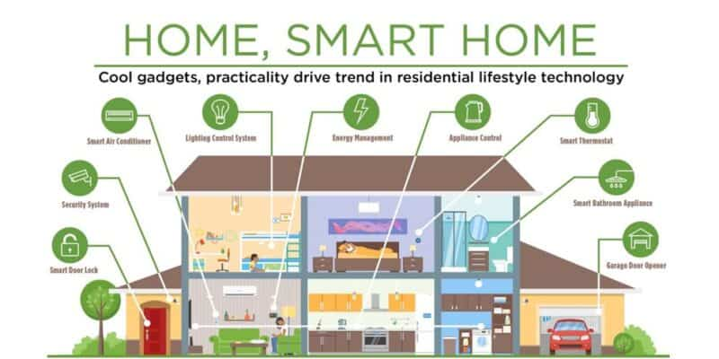

Figure 1. General model of smart home.

Currently, smart home has been a potential market with a global market of up to billions of dollars. Not only that, the North American market alone, according to the statistics, is completely reasonable to assume that this is the future of a house that we need to have.

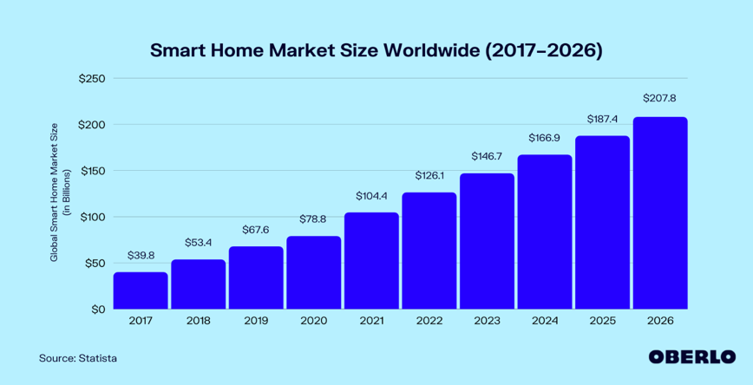

Figure 1. World Smarthome market growth chart

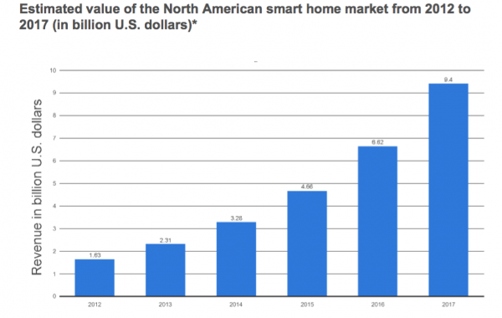

Figure 1. Smart home market growth chart only for North America market

### **Smart home models are being applied today**

#### **Smart home solutions in the world**

Currently the largest Smart home market in the world is North America. With the scale and comfort for a house with 4 people, there will be a basic design with capabilities such as: Intrusion warning, gas warning, automatic door system, security camera system, entertainment system…

Here is an example of a smart home from several manufacturers in the US and Europe, with standards from basic to high-end for a family:

Figure 1. Smart home model of Compro Technology company.

Figure 1. Smart home model of the company IEI Integration

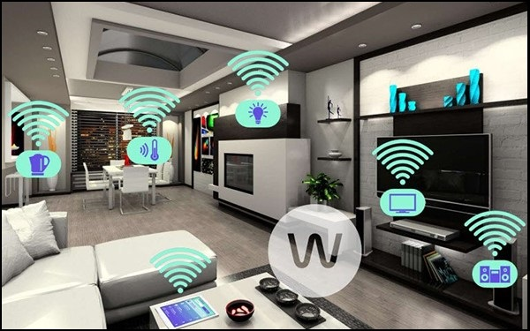

Figure 1. Smart home model Eco-Future-World

#### **Smart home solutions in Vietnam**

In Vietnam, not outside of the smart home technology flow, there have been many old and new manufacturers entering this potential market, led by BKAV and Lumi Smart home. With full functions like foreign manufacturers, plus factors suitable for the Vietnamese market, they currently have a significant advantage over foreign manufacturers in Vietnam.

Figure 1. Smart home model of BKAV

Figure 1. Smart home model of Lumi

## **Select design direction**

Smart home is a broad topic and has many problems. Depending on the intended use of the owner to design, an important part of the smart home system is the control and monitoring system.

In the past, smart homes were purely in the imagination as well as in the movies. Thanks to the continuous development of science and technology, smart home solutions are increasingly rich and convenient for users.

From the beginning, smart home only has remote control devices within the house to serve some human needs. Next is the automation of devices in the house with the ability to automatically adjust to the environment as well as the user.

Then, with the development and spread of the internet, people came up with a solution to connect and control home appliances through the internet and add conveniences such as safety systems, computing power, etc. energy usage, etc. helps the owner to control the device at a distance, not confined to the premises of the house anymore.

Security is also a top priority, because along with an internet connection, the possibility of being hacked into the system to gain control also increases. Owners can use their own passwords to log in to the system as well as the house through forms such as Passcode, fingerprint security, iris security... Accompanied by the ability to warn of intruders to help homeowners detectable anywhere with Wifi/GPRS connection.

And recently, the trend of controlling devices by voice has also been added to the smart home building solution, making it easier for everyone in the house to use. In the future, thanks to new technological devices combined with artificial intelligence, the house can distinguish each member's voice and remember the habits of each family member.

Figure 1. Development trend of smarthome

Currently, in Vietnam, the solution to build smart homes with control and monitoring systems via the internet is still the most popular and developed because it is suitable with existing technological capabilities and economic conditions.

My group feels that this topic is suitable for the major of AUTO CONTROL - AUTOMATIC as well as high-tech flow, so in this topic, my group would like to choose to design a smart house according to the solution using the system. system to control and monitor devices in the house via the internet, specifically the wifi network on a smart home model with a scale of 1000cm x 800cm with basic functions such as: automatic door opening/closing, fire monitoring and warning, gas leak warning, unauthorized intrusion warning, automatic curtains according to light, lights and fans turn on automatically according to the user and ambient temperature...

# **CHAPTER 2: OVERVIEW DESIGN OF SMART HOME CONTROL SYSTEM**

## **Structural diagram of the house and function**

### **Structural Diagram**

From an ordinary house, we choose to design a basic model for a family with 4 people, with designs including:

* Garden and periphery
* 1 living room
* 1 bedroom
* 1 kitchen area
* 1 garage
* 1 movie entertainment room

Figure 2. Structural diagram of smart house

### **Function**

With the criteria of smart home in Vietnam, we choose the functions to create a smart home with utilities such as:

* Open door with password
* Automatic curtain system according to ambient light
* Temperature and humidity notification system.
* The clothesline system automatically adjusts to the weather.
* Automatic movie mode at the movie theater.
* Automatic gas leak and fire alarm system.
* Automatic air conditioning system, lights, fans.
* Remote control system via phone app.

Figure 2. Functions to use

## **Working principal diagram**

### **Electronic system**

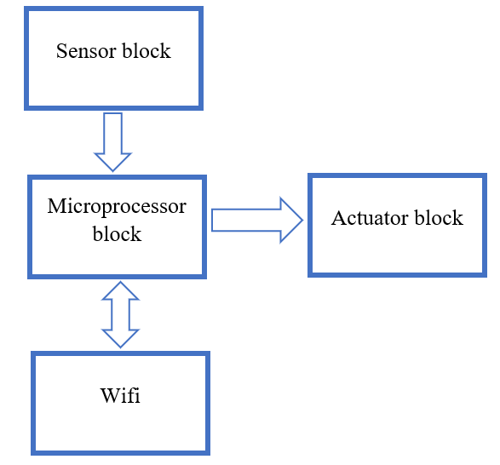

Figure 2. The schematic diagram of the working principle of the electronic system

1. *Sensor block:*

* Temperature sensor: the output signal is an analog signal.
* Humidity sensor: the output signal is a digital signal.
* Motion sensor: the output signal is a digital signal.
* Gas sensor: the output signal is a digital signal.
* Infrared sensor: the output signal is a digital signal.
* Light sensor: the output signal is a digital signal.
* Rain sensor: the output signal is a digital signal.

1. *Processing block:*

* Arduino Nano.
* MCU ESP32.

1. *Automatic control block via Blynk application.*

* Node MCU ESP32
* Wi-Fi
* Blynk App

1. *Executive block:*

* Garage door.
* Doors.
* Bedroom and movie room curtains.
* Clothesline.
* Fan, light.
* Siren.

### **System circuit diagram**

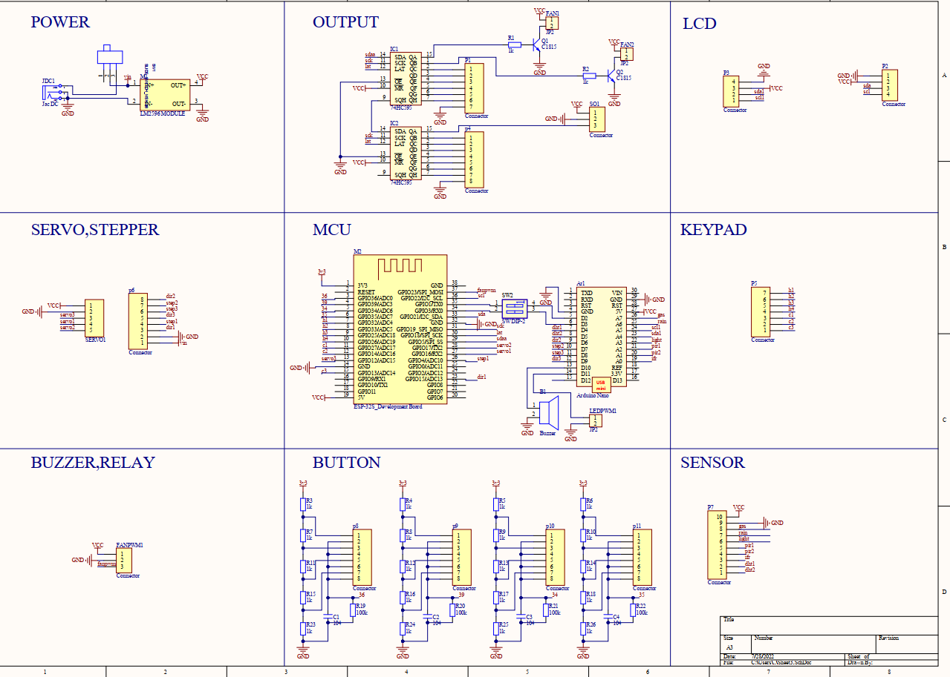

Figure 2. System circuit diagram.

# **CHAPTER 3: MICROPROCESSORS – CONTROL BLOCK**

## **Specification**

* The main idea of our project is connecting the sensors value from the sensors and then control the actuators from microprocessors.
* We can control our smart home system both in manual and auto mode (through application).
* In our project we have 2 DHT11 sensor for temperature and humidity data collection, 2 motion sensors (PIR HC-SR501) for detecting activity, 1 rain sensor for clothesline automation system, 1 light sensor for controlling the light in front of smart home, 1 infrared sensor for turning on and off stair lights automatically, 1 Peltier cooling module for the air conditioning part so we need at least 7 digital pins and 1 analog pin.
* And we also have 3 fans, 3 stepper motors and 2 servo motors, buzzers, lights for the actuators block.
* For the display, we use 3 LCD 16x2.
* In this project we chose 1 Arduino Nano and 1 Node MCU ESP32 chips because:
* ESP32 for the remote-control part from the Blynk application because ESP32 has Wi-Fi application
* Enough I/O pins
* Platform and libraries support (Arduino, Blynk, ...)
* Low price
* Easy to program
* We are familiar with

## **Introduction of Arduino Nano**

### **General structure**

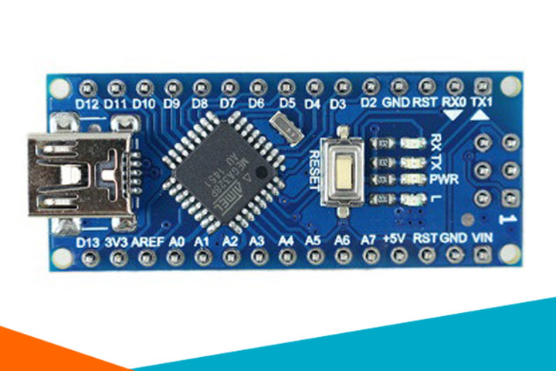

Figure 3. Hardware Architecture of Arduino Nano

The Arduino Nano is a microcontroller board based on the Atmega328 chip. It has 14 digital I/O pins, 8 analog Pins, 2 reset pins and 6 can be used for pulse width modulation. There are 6 analog input pins that allow us to connect external sensors to collect data, using a 16MHz frequency quartz oscillator, there is a USB connection port to We load the program into the board and a power supply pin for the circuit, an ICSP header, a reset button. It contains everything needed to support the microcontroller, power supply to the Arduino can be from the computer via the USB port or from a dedicated power supply converted from AC to DC or a power supply. taken from the battery.

### **Source block**

The Arduino can be powered via a USB connection or with an external power supply. The power source is selected automatically. The microcontroller system can be operated by an external supply from 6V to 20V. However, if supplied with less than 7V, the 5V pin may supply less than 5V and the microcontroller system may be unstable. If more than 12V is supplied, the voltage regulator may overheat and endanger the board. Recommended range is 7V to 12V.

* Pin Vin: Arduino input voltage when we use an external power source (different from 5V source taken from USB or power through a separate power jack). We can supply power through this pin.
* 5V pin: Provides power to the microcontroller and other components on the board and provides power to peripheral devices when connected to the board.
* 3.3V pin: Provides power for sensor devices.
* GND pin: Ground pin.
* Aref pin: Analog input voltage reference.
* IOREF pin: Provides voltage for the microcontroller to operate. A properly configured shield can read the IOREF pin voltage and select the appropriate source or trigger the voltage converter to work at 5V or 3.3V.

### **Memory**

Atmega328 chip has 32KB (with 0.5KB used for bootloader). It also has 2KB SRAM and 1KB EEPROM.

### **Specifications**

Arduino Nano pinout contains 14 digital pins, 8 analog pins, 2 reset pins & 6 power pins

The digital pins we can configure to be input pins from peripheral devices or as pins to transmit signals to peripheral devices. By using pinMode(), digitalWrite() and digitalRead() functions. Each pin can supply or receive a maximum current of 40mA and has an internal pull-up resistor (unconnected by default) of 20 - 50 kOhms. There are also some pins with special functions:

* Pins 1, 2: Serial pins (These two pins receive RX and transmit TX are used for TTL serial data transmission. The RX and TX pins are connected to the corresponding pins of the USB to TTL serial chip)
* Pins 6, 8, 9, 12, 13 and 14: PWM pin (Each of these digital pins provides an 8-bit pulse width modulated signal. The PWM signal can be generated using the analogWrite() function)
* Pins 5, 6: Interrupt (When we need to provide an external interrupt to the processor or other controller, we can use these pins. These pins can be used to enable interrupts INT0 and INT1 respectively using the attachInterrupt() function. The pins can be used to trigger three types of interrupts such as interrupt on low, increase or decrease interrupt level and change interrupt value)
* Pins 13, 14, 15 and 16: SPI communication (When you don't want the data to be transmitted asynchronously, you can use these serial peripheral pins. These pins support synchronous communication with SCK. Although the hardware has this feature, the Arduino software does not. So, you have to use SPI library to use this feature)
* Pin 16: Led (When you use pin 16, the onboard led will light up)
* Pins 18, 19, 20, 21, 22, 23, 24, 25 and 26 : Analog I/O (As mentioned earlier the UNO has 6 analog input pins but the Arduino Nano has 8 analog inputs (19 to 26), marked A0 to A7. This means you can connect to 8 analog input channels for processing. Each of these analog pins has a 1024-bit resolution ADC (so it will give 1024). By default, the pins are measured from ground to 5V. If you want the reference voltage to be 0V to 3.3V, a 3.3V source can be connected to the AREF pin (18th pin) using the analogReference() function. Like the digital pins in the Nano, the analog pins also have several other functions)
* Pins 23, 24 like A4 and A5: standard I2C . communication (When SPI communication also has its disadvantages such as needing 4 pins and limited to one device. For long distance communication, it is necessary to use the I2C protocol. I2C support with only two wires. One for pulse (SCL) and one for data (SDA). To use this I2C feature, we need to import a library called Wire Library)
* Pin 18: AREF (Reference voltage for input used for ADC conversion)
* Pin 28 : RESET (This is the reset pin of the circuit when we press the button on the board. Usually used to be connected to switches to use as reset button)

## **Node MCU ESP32**

### **What is ESP32**

ESP32 is a low-cost System on Chip (SoC) Microcontroller from Espressif Systems, the developers of the famous ESP8266 SoC. It is a successor to ESP8266 SoC and comes in both single-core and dual-core variations of the Tensilica’s 32-bit Xtensa LX6 Microprocessor with integrated Wi-Fi and Bluetooth.

Like ESP8266, the advantage of ESP32 is that it has integrated RF components such as a power amplifier, low-noise receiver amplifier, antenna switch, filters, and RF balun. Because there are so few additional components needed, it is quite simple to develop hardware around the ESP32.

Figure 3. ESP32 Architecture

Another crucial detail of ESP32 is that it is created utilizing TSMC's 40 nm ultra-low-power technology. So it should be simple to create battery-powered applications using ESP32, such as wearables, audio equipment, baby monitors, smart watches, etc...

### **Specifications of ESP32**

ESP32 has a lot more features than ESP8266 and it is difficult to include all the specifications in this Getting Started with ESP32 guide. So, this list illustrates some of the important specifications of ESP32 here.

* A 32-bit LX6 microprocessor with a single or dual core with a clock speed of up to 240 MHz
* 448 KB of ROM, 16 KB of RTC SRAM, and 520 KB of SRAM.
* Supports up to 150 Mbps 802.11 b/g/n Wi-Fi networking.
* Assistance with BLE and Classic Bluetooth v4.2 standards.
* 34 GPIOs that are programmable.
* Two channels of 8-bit DAC and up to 18 channels of 12-bit SAR ADC.
* There are 4 SPI, 2 I2C, 2 I2S, and 3 UART serial ports.
* Physical LAN communication with Ethernet MAC (requires external PHY).
* One SD/SDIO/MMC host controller and one SDIO/SPI slave controller.
* PWM for motors and up to 16 LED channels.
* Flash Encryption and Secure Boot.
* Hardware-based cryptographic acceleration for RSA, AES, Hash (SHA-2), and ECC.

### **Different Ways to Program**

ESP32 is very friendly, so there are many of ways to program it. Besides, ESP32 support multiple programming environments as:

* Arduino IDE
* PlatformIO IDE (VS Code)
* LUA
* MicroPython
* Espressif IDF (IoT Development Framework)
* JavaScript

Since the Arduino IDE is now a comfortable setting, we will use it to program the ESP32 in our forthcoming projects.

### **ESP32 DevKit – The ESP32 Development Board**

Espressif Systems released several modules based on ESP32 and one of the popular options is the ESP-WROOM-32 Module. It consists of ESP32 SoC, a 40 MHz crystal oscillator, 4 MB Flash IC and some passive components.

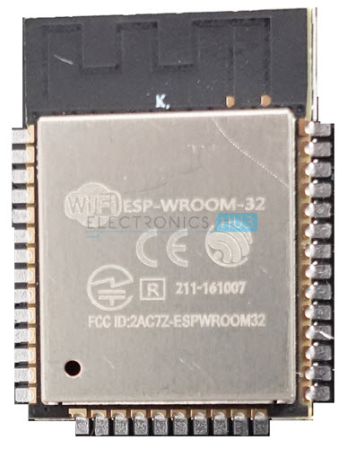

Figure 3. ESP32 DevKit Board

The PCB of the ESP-WROOM-32 Module has edge castellations, which is advantageous. As a result, third-party manufacturers create a break-out board for the ESP-WROOM-32 Module.

The ESP32 DevKit Board is one such board. It includes the ESP-WROOM-32 as the primary module in addition to some auxiliary hardware that makes connecting to the GPIO Pins and programming the ESP32 simple.

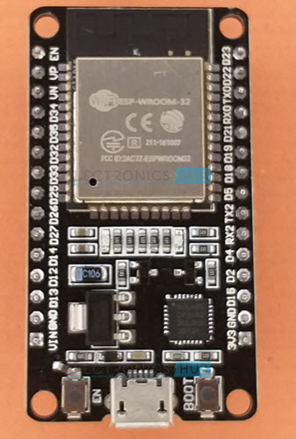

Figure 3. ESP32 Chip Module Board

### **Layout**

We will see what a typical ESP32 Development Board consists of by taking a look at the layout of one of the popular low-cost ESP Boards available in the market called the ESP32 DevKit Board.

The board I own has 30 pins (15 pins on each side). There are boards with 36 pins and boards with a few less pins. So, before establishing connections or even powering up the board, double-check the pins.

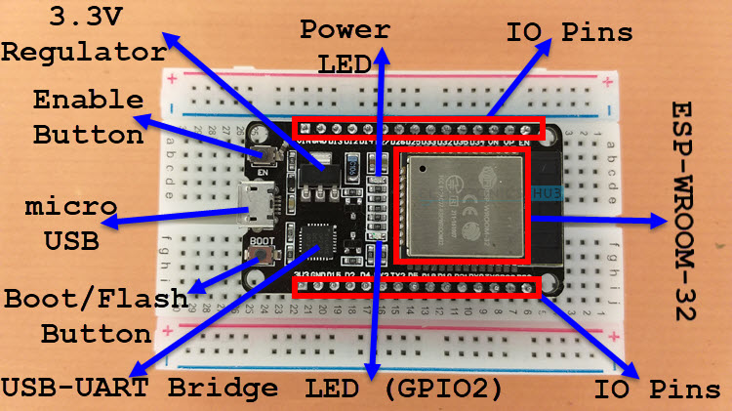

Figure 3. ESP32 Layout

The ESP32 Board contains the following peripherals:

* ESP-WROOM-32 Module
* Two rows of IO Pin
* CP2012 USB – UART Bridge IC
* micro–USB Connector (for programing and power)
* AMS1117 3.3V Regulator IC
* Enable Button (for Reset)
* Boot Button (for flashing)
* Power LED (Red)
* User LED (Blue – connected to GPIO2)
* Some passive components

An interesting point about the USB-to-UART IC is that its DTR and RTS pins are used to automatically set the ESP32 into programming mode (whenever required) and also rest the board after programming.

### **Pinout of ESP32 Board**

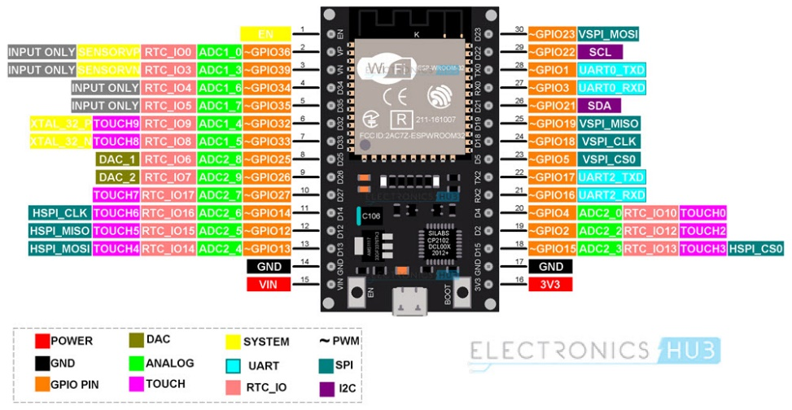

Figure 3. ESP32 pinout

### **Conclusion**

This is a thorough introduction to ESP32, a fantastic SoC with built-in Wi-Fi and Bluetooth capabilities. It is suitable for our project for learning purpose.

# **CHAPTER 4: DESIGN SYSTEM ACTUATORS SYSTEM STRUCTURE FOR SMART HOME**

## **Specification**

* In our project, we focus on some main functions of the smart home system which are the clothesline, curtains, door automation system
* Our idea of the actuators block in this system is just about the simulation model of the clothesline, curtains, and door automation system so from that we can easily understand more about those automation system of smart home in real life. And we decided to choose servo motor SG90, MG996 RC Servo motor, stepper motor 17HS401 which is also easy to use

## **Overview of the devices used in the actuator system**

* 1. **Servo motor SG90**

1. *Pin diagram*

Figure 4. Servo motor S90

Figure 4. Servo motor S90 pinout

Servo SG90 is a servo motor with 3 pins:

* Orange pin: pulse level
* Red pin: power supply 5V
* Brown pins: ground

1. *Main parameters*

Torque: 1.8kg/cm

Operating speed: 60 degrees in 0.1 seconds

Operating voltage: 4.8V(~5V)

Operating Temperature: 0 C – 55 Cº

1. *Working Principle*

When we supply pulses from 1ms-2ms, we will control the motor to rotate at an angle as desired.

1. *Application in the system*

* Open and close the main door
  1. **5.6V/2.1A DC stepper motor and A4988 control module**

1. *Pin diagram*

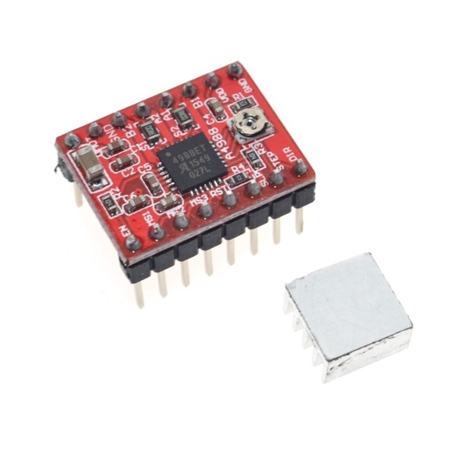

Figure 4. A4988 module

Figure 4. A4988 module pinout

Figure 4. Circuit diagram of stepper DC and A4988

1. *Working Principle*

* The protocol for controlling the number of steps and the direction of rotation is very simple.
* 5 levels of step adjustment: 1; 1/2; 1/4; 1/8 and 1/16 steps.
* Adjust the rated current for the motor by potentiometer.
* Has short circuit protection, over temperature protection, voltage drop protection and reverse current protection.

Turn the motor on and off via the ENABLE pin, the LOW level is on the module, the HIGH level is off

Motor rotation direction control via DIR . battery

Stepper motor control via STEP pin, each pulse corresponds to 1 step (or microstep)

Select the operating mode by setting the logic level for pins MS1, MS2, MS3

The Sleep and Reset pins are connected together.

1. Application in the system

Use as a motor to pull the curtains of the cinema, bedroom, and clothesline.

* 1. **MG996 RC Servo Motor**

1. *Description*

* MG996 RC Servo Motor is the most commonly used in metal robot arm designs. The MG996 RC Servo motor has strong traction, the joints and gears are made entirely of metal, so it is durable, the motor has a built-in driver that controls the motor inside according to the pulse-rotating mechanism, so it is very Easy to use.

1. *Specifications:*

* Type: Analogue RC Servo.
* Operating voltage: 4.8-6.6Vdc.
* Dimensions: 40x19x43mm.
* Weight: 55g.
* Traction:

+ 3.5 kg/cm at 4.8V voltage.

+ 5.5 kg/cm at 6V voltage.

* Spin speed:
* 0.17s/60ºC (4.8V no load).
* 0.13s/60ºC (6.0V no load).

1. *Pins configuration*

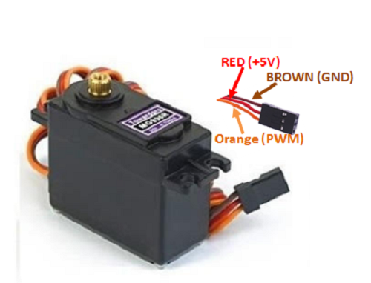

Figure 4. MG996 RC Servo Motor Pinout

|  |  |  |
| --- | --- | --- |
| Number of wire | Color of wire | Description |
| 1 | Brown | This wire connects with Ground of the system |
| 2 | Red | This wire connects with the voltage source (+5V) |
| 3 | Orange | The PWM signal is fed through this wire to control the motor |

Table 4. MG996 RC Servo Motor pinout description

1. *Application of the system*

* Open and close the garage
  1. **Stepper motor Size 42 17HS8401**

1. What is Stepper motor

* Stepper motor is a type of electric motor that converts electrical energy into mechanical energy. Used to convert control signals in the form of discrete electrical pulses consecutively into angular motions. This motion can be linear or angular.

1. Picture of Stepper motor 17HS8401

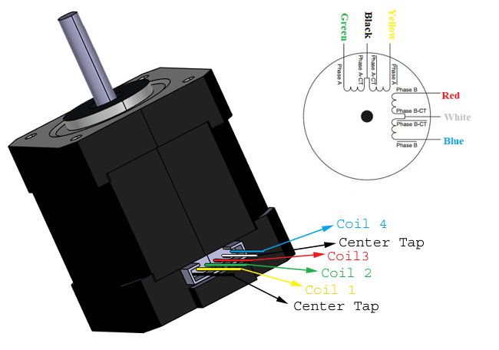

Figure 4. Stepper motor 17HS8401

1. Specifications

|  |  |
| --- | --- |
| Product Name | 40BYGH48P170 |
| Size | 42*42*48MM |
| Phase | 2 |
| Step Angle | 1.8° |
| Shaft | “D” 5MM |
| Outlet way | “4” plug line |
| Color | Silver + black |

Table 4. Stepper motor 17HS8401 specification

## **Device modules used in model and function**

### **Garden and periphery**

1. *Function*

* The door light automatically turns on when someone is in front of the door, turns off 3 seconds after the person leaves.
* Security by Passcode, when entering the wrong password 3 times, the buzzer will sound an alarm.

1. *Processor*

* 1 Arduino nano board: Receives and processes signals from sensors and executes programmed commands for sensors and devices mounted on the board.

1. *Executive structure*

* 1 motion sensor at the gate, when it detects someone appears, the light will light up, automatically turn off when the person leaves after 3 seconds.
* 1 Passcode 4x4 mounted at the door with a 4-pin password. If the password is correct, the door will open

1. Flowchart

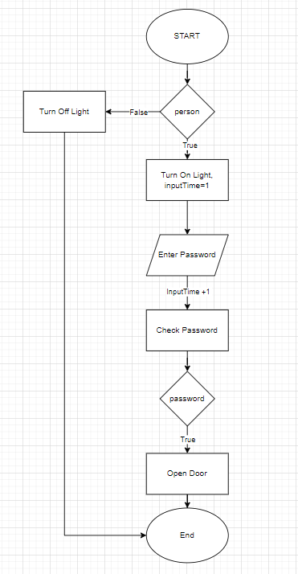

Figure 4. Flowchart of garden and periphery system

Figure 4. Flowchart of the password system

### **Living room**

1. *Function*

* Open the door automatically when entering the correct password, or use the door opening function on the phone app.
* Lights and fans automatically turn on when someone enters.
* Notification of current temperature and humidity in the house.
* Alarm when the room temperature rises above the specified level.
* The stairs light automatically turns on when someone passes, turns off automatically after 3 seconds.

1. *Processor*

* 1 Arduino nano board: Receives, processes signals from sensors and executes programmed commands for sensors and devices mounted on the board.
* 1 MCU board ESP32: Receive and process signals from devices on other nano boards and send data to the phone application.

1. *Executive structure*

* 1 servo motor is responsible for opening and closing the main door when receiving a signal from the Arduino Nano and responding when entering the correct password or opening the door command from the phone application.
* 1 infrared sensor on the stairs, when detecting someone entering the house, it will automatically turn on the lights and fans.
* The buzzer will sound an alarm when the room temperature rises above the specified limit.
* Keypad and screen enter the password, when the user enters the correct code, the servo motor will rotate and open the door.
* 1 DHT11 temperature and humidity sensor, and 1 LCD screen: the indoor temperature and humidity will be monitored by the sensor and the parameters will be displayed on the LCD screen.
* 4 buttons to turn ON/OFF the light, the fan, OPEN/Close the door, and RAISE/UNRAISE alarm

1. *Flowchart*

Figure 4. Flowchart of the living room

### **Parking garage**

1. *Function*

* Open and close the door through Blynk application.

1. *Processor*

* Share Arduino Nano board with living room: Receive, process signals from sensors and execute programmed commands for sensors and devices mounted on the board.

1. *Executive structure*

* 1 stepper motor with garage door opening/closing function

### **Sleeping room**

1. *Function*

* Curtains system open and close by manual button or control it directly through the phone interface.
* Display of temperature and humidity through LCD screen.
* Automatically adjust the temperature by Peltier Cooling Module

1. *Microprocessor*

* 1 Arduino nano board: Receives and processes signals from sensors and executes programmed commands for sensors and devices mounted on the board.

1. *Execution structure*

* 1 stepper motor and gear-belt system to pull the curtain open/close and 1 light sensor to control the motor to open and close the curtain by control signal. Curtains can be controlled open and closed via the phone interface.
* 1 Peltier cooling module with the cooling system is controlled via a stepper motor, thereby helping to adjust the room temperature automatically.
* 1 DHT11 temperature sensor and 1 LCD screen: the room temperature will be monitored by the sensor and the parameters displayed on the LCD screen; Peltier Cooling Module will adjust the room temperature.

1. *Flowchart*

Figure 4. Flowchart of the bedroom

### **Entertainment/movie room**

1. *Function*

* Private movie mode: When selected will turn on the projector, fan and turn off the lights, draw the curtain.

1. *Processor*

* 1 Arduino nano board: Receives and processes signals from sensors and executes programmed commands for sensors and devices mounted on the board.

1. *Executive structure*

* Stepper motor and gear-belt system pull the curtain open/close, controlled through a button. If the curtains are closed, then turn on the TV and if the curtains is opened, then close turn off the TV.
* Fan and lights are controlled through Blynk application.

1. *Flowchart*

Figure 4. Flowchart of the entertainment room

### **Kitchen**

1. *Function*

* Warn when there is an intruder through the window.
* Alarm when the temperature rises above the specified level.
* Alarm when the gas concentration exceeds the specified level.
* The clothesline automatically retracts when it rains.

1. *Processor*

* 1 Arduino uno R3 board: Receives, processes signals from sensors and executes programmed commands for sensors and devices mounted on the board.

1. *Executive structure*

* A stepper motor and rain sensor are located outside the kitchen wall, which is responsible for pulling the clothesline into the eaves when it rains.
* Fans and lights with controllability via phone app.
* The motion sensor located near the window has the function of sending a signal to the circuit board to turn on the alarm when it detects an intrusion.
* MQ2 gas sensor: an alarm will sound when the gas concentration parameter from the MQ2 sensor exceed the specified level.

1. *Flowchart*

Figure 4. Flowchart of the kitchen

# **CHAPTER 5: ELECTRONIC COMPONENTS, DESIGN MONITORING AND ALARM SYSTEM FOR SMART HOME**

## **Specification**

* We have some other ideas which are collecting the temperature and humidity of our home so that we used DHT11 sensor for simulation model
* Peltier cooling module for the air conditioning system
* Rain sensor for the clothesline automation system
* Motion sensor for anti – theft system
* Infrared sensor for identifying human goes upstairs and then turn on and off the lights
* Light sensor for control lights
* Keyboard for the security in the living room
* LCD for display

## **Electric components and overview of sensors used in monitoring and warning systems**

### **Temperature and humidity sensor DHT11**

1. *Pinout Diagram:*

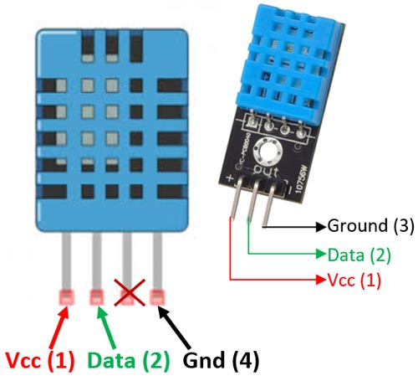

Figure 5. DHT11 sensor pinout

The DHT11 is a basic, low cost digital temperature and humidity sensor.

The DHT11 is a commonly used Temperature and humidity sensor that comes with a dedicated NTC to measure temperature and an 8-bit microcontroller to output the values of temperature and humidity as serial data.

|  |  |  |
| --- | --- | --- |
| **No:** | **Pin Name** | **Description** |
| **For DHT11 Sensor** | | |
| 1 | Vcc | Power supply 3.5V to 5.5V |
| 2 | Data | Outputs both Temperature and Humidity through serial Data |
| 3 | NC | No Connection and hence not used |
| 4 | Ground | Connected to the ground of the circuit |
| **For DHT11 Sensor module** | | |
| 1 | Vcc | Power supply 3.5V to 5.5V |
| 2 | Data | Outputs both Temperature and Humidity through serial Data |
| 3 | Ground | Connected to the ground of the circuit |

Table 5. DHT11 pinout description

1. *DHT11 Specifications:*

* Operating Voltage: 3.5V to 5.5V
* Operating current: 0.3mA (measuring) 60uA (standby)
* Output: Serial data
* Temperature Range: 0°C to 50°C
* Humidity Range: 20% to 90%
* Resolution: Temperature and Humidity both are 16-bit
* Accuracy: ±1°C and ±1%

1. *Working principle of temperature sensor DHT11*

* To be able to communicate with DHT11 according to the standard 1-pin microprocessor, follow 2 steps:
* Send signal you want to measure (Start) to DHT11, then DHT11 confirm again.
* Once communicating with the DHT11, the Sensor sends back 5 bytes of data and the measured temperature.

1. *Application of temperature and humidity sensors in the system*

The temperature and humidity signals collected from this sensor will be applied in monitoring temperature and humidity, automatically disabling when the measured temperature value is greater than the pre-set value. In addition, the signal from this sensor will be used to turn on the siren when the temperature exceeds a certain level. The collected temperature will be continuously sent to the phone application for users to monitor.

### **Gas sensor MQ2**

1. *Introduction of MQ2 gas sensor module*

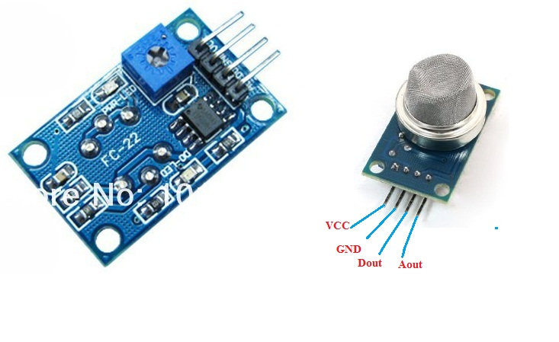

Figure 5. MQ2 gas sensor module

Gas sensor module.

* Operating voltage 3 – 5 volts.
* Connect 4 pins to 2 power supply pins (VCC and GND) and 2 output signal pins.
* Supports both analog and TTL outputs. Analog output 0 – 4.5V proportional to gas concentration, low level active TTL input.

MQ2 is a gas sensor, used to detect potentially flammable gases. It is composed of the semiconductor SnO2. This substance has a low sensitivity to clean air. But when in the environment there is a combustible substance, its conductivity changes immediately. It is thanks to this feature that a simple circuit is added to convert from this sensitivity to voltage.

When the environment is clean, the output voltage of the sensor is low, the output voltage value increases as the concentration of combustible gas around the MQ2 sensor is higher nMQ2 sensor works very well in liquefied petroleum gas, H2, and other combustible gases. It is widely used in industry and civil because of its simple circuit and low cost.

MQ2 works very well in liquefied petroleum gas, H2, and other combustible gases. It is widely used in industry and civil because of its simple circuit and low cost.

1. *Structure diagram and working principle of the module*

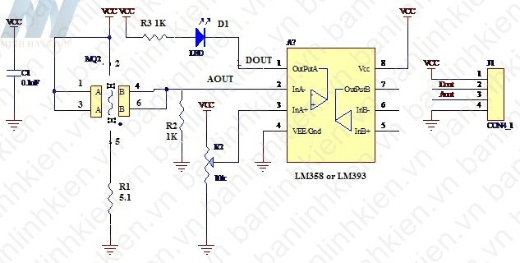

Figure 5. Structure of the MQ2 gas sensor module

MQ2 is a gas sensor, used to detect potentially flammable gases. It is composed of the semiconductor SnO2. This substance has a low sensitivity to clean air. But when in the presence of flammable substances, its conductivity changes immediately. It is thanks to this feature that a simple circuit is added to convert this sensitivity to voltage. When the environment is clean, the output voltage of the sensor is low, the output voltage value increases as the concentration of MQ2 ambient flammable gas is higher.

When detecting a gas leak, the module will output a signal in two forms: DOUT digital and AOUT_analog. Users can choose the appropriate signal depending on the purpose of use.

The circuit has two output pins, Aout and Dout. In there:

* About: analog output voltage. It runs from 0.3 to 4.5V, depending on the ambient gas concentration MQ2.
* Dout: digital output voltage, value 0 or 1 depends on reference voltage and gas concentration measured by MQ2.

Having a digital output pin Dout is very convenient for us to have simple applications, without the need for a microcontroller. Then we just need to adjust the variable resistor value to the concentration value we want to warn. When the measured MQ2 concentration is lower than the allowable level, then Dout = 1, the buzzer will stay in standby state. When the measured flammable gas concentration is greater than the allowed concentration, the Dout =0, the buzzer will sound.

We can connect to the Relay circuit to control turning on and off lights, horns, or other warning devices.

One difficulty when working with MQ2 is that it is difficult to convert the Aout voltage to the ppm concentration value. Then from there display and alert in ppm. Because the return voltage value of each gas is different, it is also affected by temperature and humidity.

In your device, you can define the alarm point manually:

* First measure the clean air state, the obtained value Vout1.
* Let the gas from the lighter leak out. We see the Aout value increase. When the gas distance from the lighter is reasonable and corresponds to the dangerous starting gas concentration, we record the value Vout2. We choose the value Vout2 as the alarm threshold value. If the measured value is larger, we will warn you.
* Adjust the rheostat so that the voltage measured at pin 3 of L358 = Vout2.

1. *Application of the module*

Gas sensors have great applications in life:

* Detecting gas leaks in the water.
* In industry used to detect flammable substances.
* Flammable gas detector.

### **Motion sensor HC-SR510**

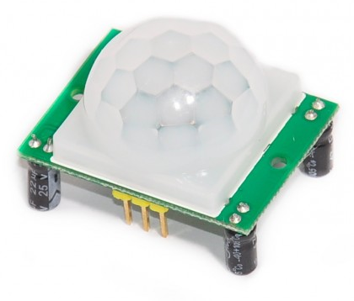

Figure 5. Motion sensor module HC-SR510

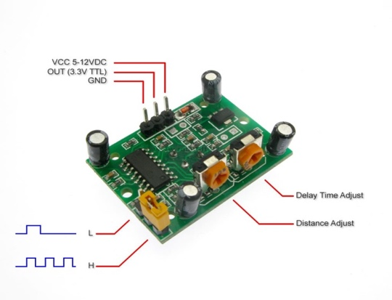

Figure 5. HC-SR510 motion sensor input

1. *Specifications:*

* Voltage usage: 4.5-20V
* Output voltage: 0-3.3V
* Pins: Vcc, OUT, GND.
* 2 operating modes
  + (L) no repeat activation
  + (H) repeat activation.
* Delay time: adjustable between 0.5-200S.
* PCB Size:32mmx24mm
* Scan angle <100 degrees.
* Using sensor: 500BP
* Detection distance: 2-4.5m

1. *The working principle of the module*

Working mechanism of infrared sensor PIR: is a sensor that receives infrared rays emitted from infrared-emitting objects such as the human body (or any heat source).

PIR sensors always have a sensor (sensor eye) with 2 units (element). In front of the sensor is a prism (usually made of plastic), made in the style of a fresnel prism. This fresnel prism has the effect of blocking and dividing into many zones (zones) that allow infrared rays to enter the sensor's eyes. Without the fresnel prism, all the radiation of the medium would be treated as if there was only one zone bouncing off the sensor's eyes, so it would have no motion discrimination effect, and would be extremely sensitive to any disturbances. any change in the temperature of the environment.

2 units of the sensor eye have the effect of dividing into 2 electrodes. One is positive (+) and the other is negative (-). When these two units are sequentially activated (one is done, then the other) is generated an electrical pulse, which activates the sensor. Because of this principle, when someone walks in a direction perpendicular to the sensor's control area (arrow direction), body temperature from this person (infrared radiation) will in turn activate each sensor unit and make alarm sensor.

1. *Application of the module*

This module is used to detect motion in its workspace. Thanks to this function, it can be used to detect motion when there is an intruder in the window or the back door of the kitchen.

### **IR Infrared Obstacle Avoidance Sensor Module**

1. *Descriptions*

* The infrared obstacle sensor is adaptable to the environment, having a pair of infrared transmitters and receivers. Infrared rays emit a certain frequency, when detecting the direction of transmission with obstacles (reflective surface), reflected into the infrared receiver lamp, after comparison, the blue light will light up, at the same time the signal will be sent to the receiver. output signal (a low-order signal).
* Effective working distance 2~5cm, working voltage is 3.3V to 5V. The light sensitivity of the infrared obstacle sensor is adjusted by the potentiometer, the sensor is easy to assemble, easy to use, etc.

1. *Specifications*

* Comparator using LM393, stable working
* Working voltage: 3.3V – 5V DC.
* When the power is on, the red power indicator light is on.
* 3mm screw hole, easy to fix, install.
* Size: 3.2cm * 1.4cm
* The module has been compared the threshold voltage through the potentiometer, if used in common mode, please do not arbitrarily adjust the potentiometer.

1. *Diagram*

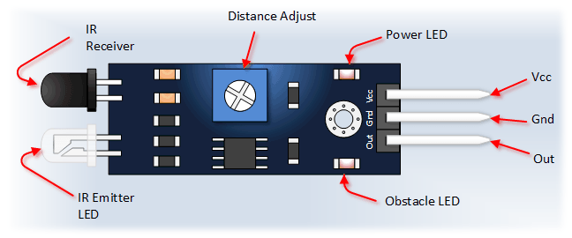

Figure 5. Diagram of IR Infrared Obstacle Avoidance Sensor Module

* Pins
* VCC: 3.3V to 5V conversion voltage (can be directly connected to 5V and 3.3V microcontrollers)
* GND: External GND
* OUT: digital output (0 and 1)

### **Light Sensor**

1. *Descriptions*

* The light sensor module is an electronic component whose resistance varies with the light entering it. The photoresistor is made of a high impedance semiconductor and has no junctions. In the dark, photoresistors have resistances up to several MΩ. When there is light, the resistance drops to a few hundred Ω Accuracy: ±5%RH and ±2o
* The operation of photoresistors is based on the photoelectric effect in the mass of matter. When a photon with enough energy hits it, it knocks electrons out of the molecule, becomes free in the mass, and makes the semiconductor a conductor. The degree of electrical conductivity depends on the number of photons absorbed.

1. *Specifications*

* Operating voltage: 3.3V-5V
* PCB Size: 3cm*1.6cm
* Green LED indicates power and light
* Comparator IC: LM393
* VCC: 3.3V-5V
* GND: 0V
* DO: Digital signal output (0 and 1)
* AO: Analog Output (Analog signal)

1. *Pinout*

* AO: Analog signal
* DO: Digital output signal
* GND: Connect Mass- Cathode
* VCC: Connect 3.3V to 5V

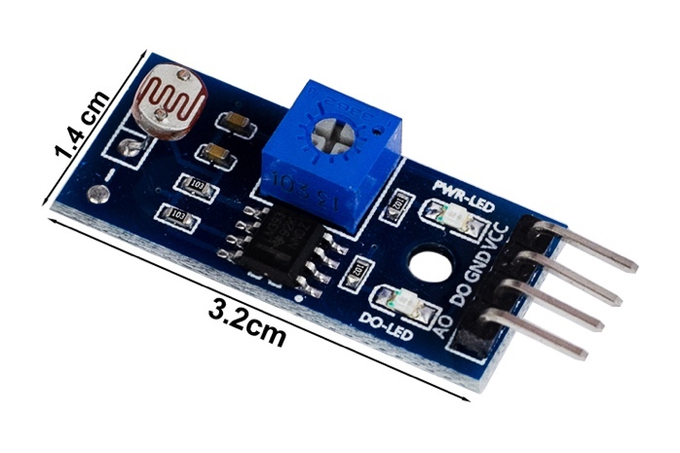

Figure 5. Light sensor pinout

1. *Principle diagram*

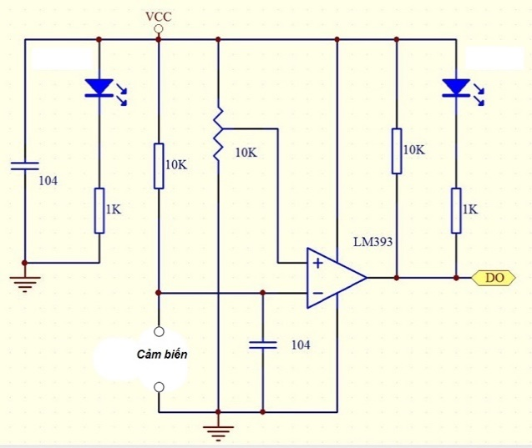

Figure 5. Light sensor principle diagram 1

* The light sensor module has 2 output signals D0 and A0, the output A0 is taken from the photoresistor and put into the comparator lm393 to give 0V and 5V voltage levels. The rheostat adjusts the sensitivity of the sensor, you can optionally change the rheostat so that the sensor outputs level 1 with the appropriate light intensity.

1. *Application*

* Manufacture automatic night lights, line detectors, measure light intensity.
* Use the digital function to make the lights turn on automatically when it's dar
* The DO output will output level 1 when it's dark, combined with the NPN tran and led lights to make a night light that automatically lights up when it's dark, you can adjust the rheostat to adjust the most suitable light time.

*Principle diagram*

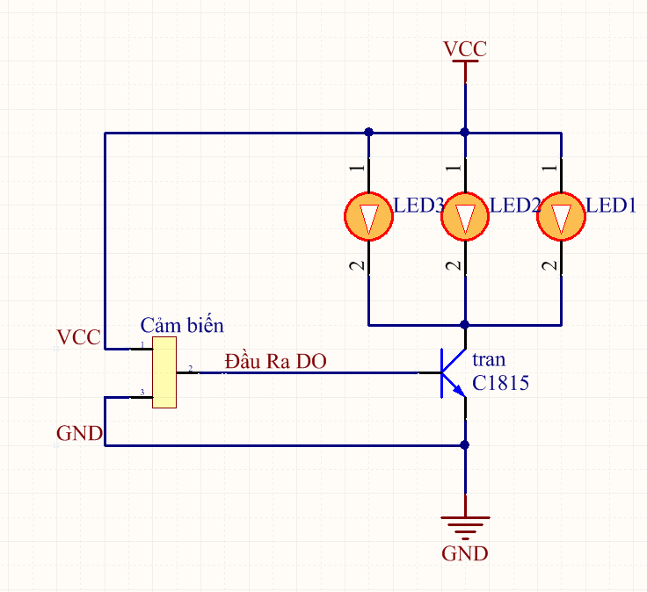

Figure 5. Light sensor principle diagram 2

1. *Working principle*

* When it is dark, the sensor gives a level of 1 to open C1815 and the led lights up.
* When it's bright, the sensor outputs 0 tran C1815 no lead, led off.

### **Rain sensor**

1. *Descriptions*

* Rain sensor is used to detect water level, rain, or watery environments. The rain sensor circuit is placed outdoors to check if it is raining, thereby transmitting the control signal to close / disconnect the relay.
* *The rain sensor circuit consists of 2 parts:*
* Rain sensor mounted outdoors
* The sensitivity regulator needs to be shielded
* The rain sensor circuit works by comparing the voltage of the outdoor sensor circuit with a predetermined value (this value can be changed through a blue rheostat) thereby emitting a signal to turn on / off the relay. le through pin D0.
* When the sensor is dry (it is not raining), the D0 pin of the rain sensor module will be kept high (5V-12V). When there is water on the sensor surface (it is raining), the red LED will light up, pin D0 is pulled low (0V).

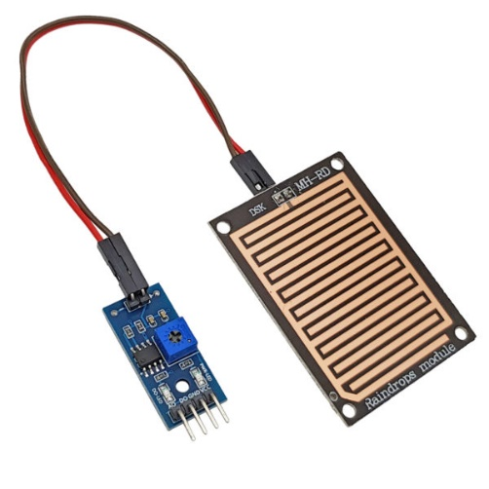

Figure 5. Rain sensor

1. *Specifications*

* Voltage: 5V
* Power LED (Blue)
* Rain warning LED (red)
* Operation is based on the principle: Water falling on the board will create a conductive medium.
* There are two types of signals: Analog (AO) and Digital (DO).
* Signal form: TTL, output 100mA (Can be used directly Relay, Small capacity whistle ...)
* Adjust the sensitivity by rheostat.
* Use LM358 to convert AO -> DO
* Dimensions: 5.4*4.0mm
* 1.6mm thick

### **Peltier Cooling Module**

1. *Descriptions*

* Hot and cold clams, also known as super-technology semiconductor wafers or Peltier chips, are semiconductors that have cooling properties on one side, the other side is heated. More specifically, a small, light, and powerful semiconductor piece 50W) this helps to absorb heat from the surface with the symbol above and discharge it to the other surface => the amount of heat on the other surface will be equal to the sum of the heat absorbed from the surface with the letter and the amount of heat transferred from the electricity that We put in 2 wires of this piece of semiconductor.
* Therefore, in a cooling application, the better the heat dissipation for the hot side, the colder the other side will be, possibly down to the freezing point and freezing. If you put a large voltage on the two ends of the wire, making the other side very hot without enough heat dissipation, this semiconductor piece (Peltier) will be damaged by overheating.

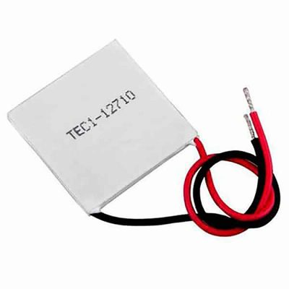

Figure 5. Peltier cooling module

1. *Configuration*

* Both hot and cold clams are composed of 2 sides, a cold side and a hot side, usually fitted with a heat sink and 2 negative and positive power cords.

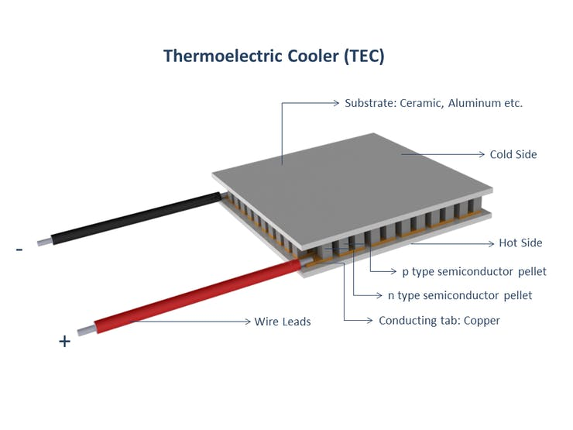

Figure 5. Peltier cooling module configuration

1. *Specifications*

* Size: 4cm x 4cm
* I(A): 5 A -10A (I tested with 10A line; it cools very quickly)
* Voltage: 3 V~ 15.4 V (DC current)
* Cooling power: 50 W, 90 W, 120 W
* 2-sided temperature difference: ~67°C (so the better the heat is dissipated, the colder the cold side)
* Maximum cooling temperature: – 6 °C. (if your heatsink is good)

*There are many types of Peltier Cooling Module with different capacities:*

* TEC1-12705: Power 50W
* TEC1-12706: Power 60W
* TEC1-12708: Power 80W
* TEC1-12710: Power 100W
* TEC1-12715: Power 150W

### **Module Relay 12V DC**

1. *Descriptions*

* High- or low-level triggers can be configured via a jumper to accommodate more trigger applications.
* Strong drive ability and stable performance with path optical isolation.
* A jumper setting trigger allows the module to be set to high or low.
* Humane interface design, all interfaces are directly connectable by terminal wiring leads, highly practical.
* Fault-tolerant design; the relay will not work even if the control wire is damaged.
* The 12VDC source is used to power the circuit in the - MODULE Relay 2 Channel 12VDC H/L. The trigger signal has the choice of triggering a high level (High - 12VDC) or a low level (Low - 0VDC) through the Jumper on each relay. Suitable for electronics with a signal level of 12 V DC, such as microcontrollers

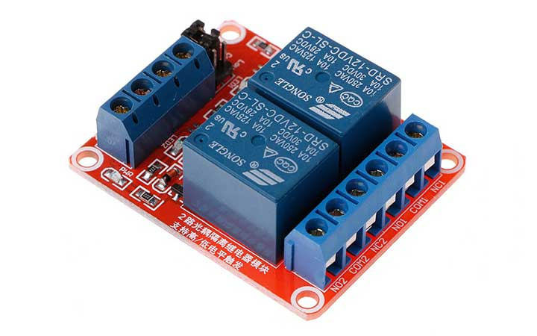

Figure 5. Module Relay 12V DC 2 channels

Figure 5. Module Relay 12V DC 1 channel

1. *Specification*

* Maximum load: AC 250V / 10A, DC 30V / 10A
* Trigger current: 5mA
* Working voltage: 12V
* Four mounting bolt holes

1. *Working principle*

Figure 5. Module Relay 12V DC working principle 1

* Relay operates on the electromagnetic induction theory.
* A magnetic field is created around an electromagnet when some current is provided.
* The relay is operational in the above image. DC current is applied to the load using a switch.
* The iron core and copper coil in the relay function as an electromagnet.
* When a DC current is given to the coil, it begins to draw the contact in the direction depicted.
* When the supply is taken away, it returns to its previous position. De energizing of relay is the term for this.

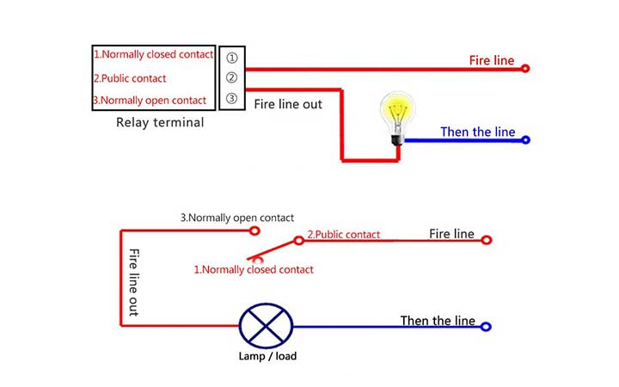

Figure 5. Module Relay 12V DC working principle 2

### **Radiator fan**

1. *Function*

* Radiator fan creates cooling air for electronic devices.

1. *Specifications*

* Power DC5V
* Rated current: 0.1A
* Power: 0.5W
* Number of revolutions: 7000 ± 10% (rpm)
* Noise: 20DBA
* Wind speed: 1.5M/S
* Lifespan: 30,000 hours.
* Dimensions: 3x3x1CM

1. *Picture*

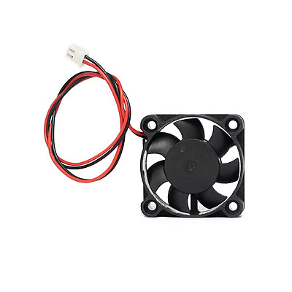

Figure 5. Radiator fan

### **LCD 16x2**

1. *What is LCD 16x2*

* An LCD 16x2 is a type of electronic display that shows data and a message. As the name implies, it has 16 Columns and 2 Rows, allowing it to display 32 letters (16 x 2), each of which is made up of 5 x 8 (40) Pixel Dots. Therefore, 32 x 40 or 1280 pixels can be used to calculate the total number of pixels in this LCD.

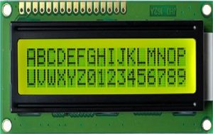

Figure 5. LCD 16x2

1. *Specifications*

* The operating voltage of this display ranges from 4.7V to 5.3V
* The display bezel is 72 x 25mm
* The operating current is 1mA without a backlight
* PCB size of the module is 80L x 36W x 10H mm
* HD47780 controller
* LED color for backlight is green or blue
* Number of columns – 16
* Number of rows – 2
* Number of LCD pins – 16
* Characters – 32
* It works in 4-bit and 8-bit modes
* Pixel box of each character is 5×8 pixel
* Font size of character is 0.125Width x 0.200height

1. *Pin configuration*

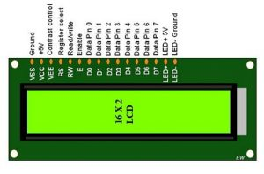

Figure 5. LCD 16x2 pinout

* Pin1 (Ground): This pin connects the ground terminal.
* Pin2 (+5 Volt): This pin provides a +5V supply to the LCD
* Pin3 (VE): This pin selects the contrast of the LCD.
* Pin4 (Register Select): This pin is used to connect a data pin of an MCU & gets either 1 or 0. Here, data mode = 0 and command mode =1.
* Pin5 (Read & Write): This pin is used to read/write data.
* Pin6 (Enable): This enables the pin must be high to perform the Read/Write procedure. This pin is connected to the data pin of the microcontroller to be held high constantly.
* Pin7 (Data Pin): The data pins are from 0-7 which are connected through the microcontroller for data transmission. The LCD module can also work on the 4-bit mode through working on pins 1, 2, 3 & other pins are free.
* Pin8 – Data Pin 1
* Pin9 – Data Pin 2
* Pin10 – Data Pin 3
* Pin11 – Data Pin 4
* Pin12 – Data Pin 5
* Pin13 – Data Pin 6
* Pin14 – Data Pin 7
* Pin15 (LED Positive): This is a +Ve terminal of the backlight LED of the display & it is connected to +5V to activate the LED backlight.
* Pin16 (LED Negative): This is a -Ve terminal of a backlight LED of the display & it is connected to the GND terminal to activate the LED backlight

1. *Working principle*

* The fundamental working tenet of an LCD is the transmission of light via modules from one layer to another. These modules will vibrate and align themselves at a 90-degree angle so that light can pass through the polarized sheet.
* These molecules oversee viewing the information on each pixel. Each pixel uses the technique of absorption of light to display the digit. The position of the molecules must be adjusted to the angle of light to display the value.
* So, this light deflection will make the human eye notice the data that will be the ingredient wherever the light gets absorbed. Here, this data will supply to the molecules & will be there till they get changed
* Currently, LCDs are widely utilized in CD/DVD players, computers, digital watches, and other devices. CRTs (Cathode Ray Tubes) have been superseded by LCDs in the screen industry since these displays require more electricity, are heavier, and are larger than LCDs.

1. *Registers of LCD*

* Data registers and command registers are the two types of registers used in LCDs. The RS pinout can be used to modify the register. It is a command register if we set it to "0," and a data register if we set it to "1.".
* *Command Register*
* The command register's primary purpose is to store instructions that are displayed on LCD. It facilitates data cleaning, moves the cursor, and manages the display.
* *Data Register*
* Data that will be displayed on the LCD is saved in the data register. Data processing then transfers to the data register after we have transmitted the data to the LCD. The data register will begin to function if we set the register value to one.

### **I2C Communication**

1. *Definition*

* I2C (Inter - Integrated Circuit) is a synchronous serial communication protocol developed by Philips Semiconductors, used to transmit and receive data between ICs using only two signal lines.
* The data bits will be transmitted bit by bit at regular intervals set by a clock signal.
* The I2C bus is often used to interface peripherals for many different types of ICs such as microcontrollers, sensors, EEPROMs, ...

1. *Working principle*

* Structure:
* I2C uses 2 signal lines:

SCL - Serial Clock Line: Generates a clock transmitted by the Master

SDA - Serial Data Line: The line to receive data.

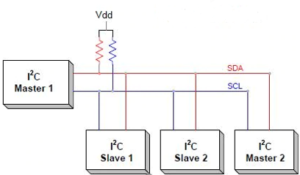

Figure 5. I2C structure

* I2C communication includes the process of transmitting and receiving data between master and slave devices, or Master - Slave.
* The Master device is a microcontroller, it is responsible for controlling the SCL signal line and sending and receiving data or commands through the SDA line to other devices.
* Devices that receive command and signal data from the Master device are called Slave devices. Slave devices are usually ICs, or even microcontrollers.
* Master and Slave are connected together as shown above. The two bus lines SCL and SDA both operate in Open Drain mode, meaning that any device connected to this I2C network can only pull these two bus lines low (LOW), but cannot pull them. to a high level. Because to avoid the case that the bus is both pulled by one device to a high level and by another device to a low level, causing a short circuit. Therefore, a resistor (from 1 to 4.7 kΩ) is required to keep the default high.
* I2C transmission frame:

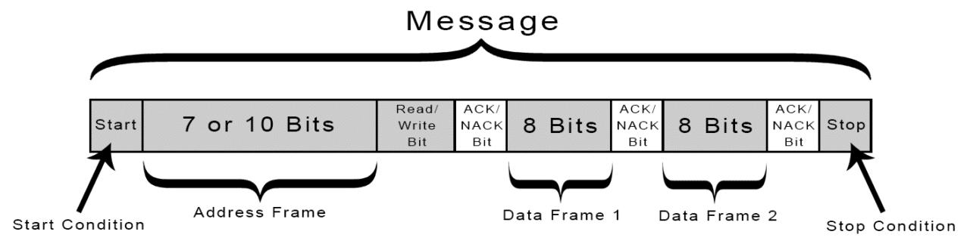

Figure 5. I2C transmission frame

* Address bit block:
* Normally, the transmission process will take place with many devices and ICs together. Therefore, to distinguish these devices, they will be assigned a fixed 7-bit physical address.

Figure 5. I2C address bit block

* Read/Write Bit
* This bit is used to determine whether the process is transmitting or receiving data from the Master device. If the Master sends data, this bit is equal to '0', and vice versa, receives data when this bit is equal to '1'.
* ACK/NACK Bit
* This bit is used to determine whether the process is transmitting or receiving data from the Master device. If the Master sends data, this bit is equal to '0', and vice versa, receives data when this bit is equal to '1'.
* Data bit block:
* Consists of 8 bits and is set by the sending device to the kernel. After these bits are sent, an ACK/NACK bit is immediately followed to confirm that the receiving device has successfully received the data. If received successfully, the ACK/NACK bit is set to '0' and vice versa.
* Data transmission process:
* Start: The Master device will send a Start pulse by pulling the SDA and SCL lines from 1 to 0.

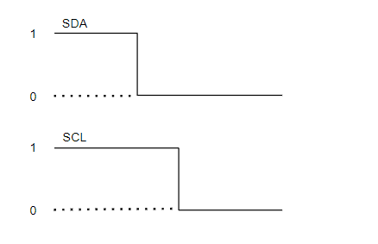

Figure 5. I2C address bit block

* Next, the Master sends the 7 address bits to the Slave that wants to communicate with the Read/Write bit.
* The slave will compare the physical address with the address it was sent to. If there is a match, the slave acknowledges by pulling the SDA line to 0 and setting the ACK/NACK bit to '0'. If there is no match, the SDA and ACK/NACK bits both default to '1'.
* The Master device sends or receives a data bit frame. If the Master sends to the Slave, the Read/Write bit is set to 0. Otherwise, if received, this bit is set to 1.
* If the data frame has been successfully transmitted, the ACK/NACK bit is set to 0 to signal the Master to continue.
* After all data has been successfully sent to the Slave, the Master will issue a Stop signal to notify the Slaves that the transmission has ended by switching SCL, SDA from level 0 to level 1, respectively.
* I2C operating modes:
* Standard mode at 100 Kbit/s.
* Low speed mode at 10 Kbit/s.

In addition, unlike the SPI interface, which can only have 1 Master, the I2C interface allows data transmission between many different Master devices and Slave devices. However, this process is a bit complicated because the Slave device can receive multiple data frames from different Master devices at the same time, which sometimes leads to collisions or errors in the received data.

To avoid that, when working in this mode, each Master device needs to detect what state the SDA line is in. If SDA is at 0, it means that there is another Master device that has control and must wait until the transmission is complete. Conversely, if SDA is at 1, it means that the SDA line is safe and in use.

1. *Picture*

Figure 5. I2C module

### **Keypad 3x4**

1. *Description*

* Punch in your secret key into this numeric matrix keypad. This keypad has 12 buttons, arranged in a telephone-line 3x4 grid. It's made of a thin, flexible membrane material with an adhesive backing (just remove the paper) so you can attach it to nearly anything. The keys are connected into a matrix, so you only need 7 microcontroller pins (3-columns and 4-rows) to scan through the pad

1. *Specifications*

* Weight: 7.5 grams
* Keypad dimensions: 70mm x 77mm x 1mm (2.75" x 3" x 0.035")
* Length of cable + connector: 85mm
* 7-pin 0.1" pitch connector

1. *Picture*

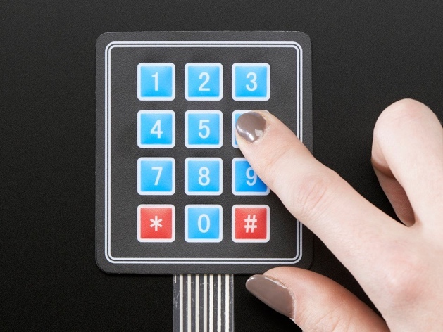

Figure 5. Keyboard 3x4

### **Button**

1. *Specifications*

* Number of pins: 4 pins.
* Current withstanding: 2A.
* Color: black.
* Shape: square.
* Dimensions: 6 x 6 x 12mmt

1. *Working principle*

* When the button is NOT pressed, pin A is NOT connected to pin B
* When the button is pressed, pin A is connected to pin B

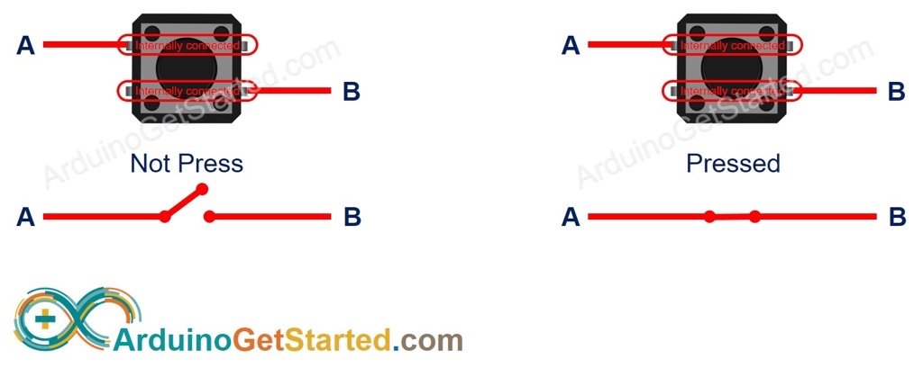

Figure 5. Button working principle

1. *Picture*

Figure 5. Button

### **Voltage Supply**

1. *12V – 5A Adapter*

* Description
* Power adapter 12V 5A, also known as 12-volt DC power supply, is designed to convert voltage from 110/220VAC AC to 12VDC DC to supply operating equipment. Power adapter 12V 5A used to power camera, hdd box, hdd docking, other electronic equipment...
* Specifications
* Input voltage: AC100-240V 50 / 60HZ
* AC plug: US standard
* Output voltage: DC12V
* Maximum output current: 5A
* Total length of source ~ 1m5
* Efficiency: > 85%
* DC Jack: 5.5*2.5mm (compatible 5.5 * 2.1mm)
* Weight: 215g
* Picture

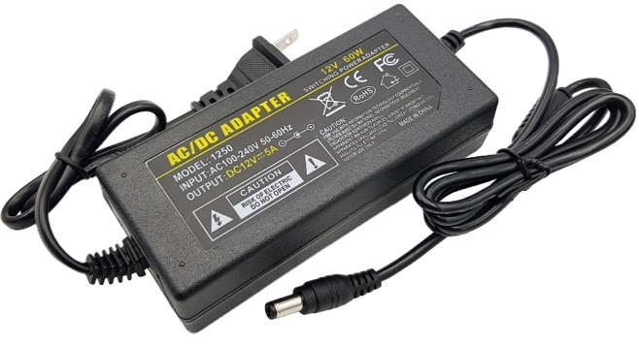

Figure 5. Adapter 12V – 5A

1. *12V – 2A Adapter*

* Description
* Power Adapter has the role of converting AC voltage into DC voltage to serve today's modern technology devices.
* Power Adapter 12V 2A is a kind of pulse source, can convert from 240VAC to 12VDC.
* Specifications
* Classification: Pulse Source
* Input power: 100V- 240VAC
* Output voltage: 12VDC
* Maximum output current: 2A
* AC input: 2-pin AC jack
* Picture

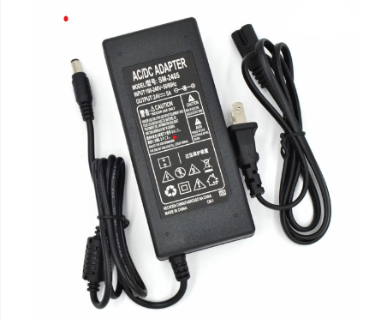

Figure 5. Adapter 12V – 5A

1. Non-Isolation Voltage Supply (5V and 12V)

* Chose an isolation voltage supply without isolation IC DC-DC converter

Figure 5. Non-Isolation Voltage Supply

### **IC 74HC595**

1. *Description*

* 74HC595 IC is a 16-pin shift register IC consisting of a D-type latch along with a shift register inside the chip. It receives serial input data and then sends out this data through parallel pins. In addition to parallel outputs, it also provides a serial output. It has independent clock inputs for the shift register and D latch. This IC belongs to the HC family of logic devices which is designed for use in CMOS applications.
* 74HC595 has two built-in registers. The first one is a shift register and the second one is a storage register. Data serially transfers to shift register bit by bit. But it transfers to the storage register only when the data latch pin is active high.

1. *74HC595 Pinout Diagram*

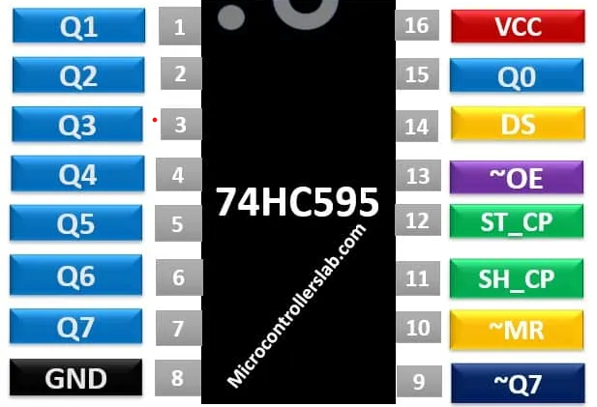

Figure 5. 74HC595 pinout diagram

* Pin 01, 02, 03, 04, 05, 06, 07, 15: Output pins

These eight pins are the output pins of the shift register. We should connect these pins with any peripheral where we want to display storage register data. Commonly used components are like LED, seven-segment displays, etc.

* Pin 08: GND

This is the ground pin and is connected to the ground of the circuit.

* Pin 09: Q7’

It is a non-inverted serial data output coming out of the eighth stage of a shift register. It is also used for cascading purposes. For instance, if we need 16 bits shift register. We can daisy-chain two 74HC595 ICs. To do this, simply connect ~Q7 pin with Serial input DS pin of 2nd 595 IC. Moreover, provides the same clock signal to both integrated circuits. In this way, two 74HC595 will work as a single 16-bit shift register. Furthermore, you can continue this process to connect as many ICs as you want to get more data width.

* Pin 10: ~MR

It is an asynchronous, active low master reset Input which is used to reset the shift register only. The 8-bit latch is not affected by this input. Applying a low signal at pin 10 will reset the shift register portion only.

* Pin 11: SH_CP

This is the clock input pin of a 74hc595 shift register. A data is shifted from the serial input pin to the 8-bit shift register on every positive transition of the clock signal applied at this pin.

* Pin 12: ST_CP

This is the active high, clock input pin of a storage register. A positive transition of a signal at this pin is used to update the data to the output pins.

* Pin 13: ~OE

The Output Enable pin is active low. When this pin is low, the data in the storage register appears at the output. On applying high signals, outputs are turned off by forcing them into the high-impedance state. However, serial output is not affected at all. For normal operations, it is kept low.

* Pin 14: DS

This is the serial data input pin, where input data is provided.

* Pin 16: VCC

A positive power supply is provided at this pin.

1. *74HC595 Features*

* It is a shift register with 8-bit serial input and 8-bit serial or 3-state parallel outputs.
* The operating voltage of this IC is from 2V to 6V.
* The output voltage is equal to the operating voltage of this IC.
* It is based on CMOS logic and therefore consumes a very low power of 80uA.
* The output source/sink current is 35mA.
* It has a characteristic of high noise immunity.
* It can be easily cascaded through pin 9 with more IC to get more outputs.
* The maximum clock frequency is 25Mhz @4.5V.
* Schmitt trigger action is provided on all inputs.

1. *74HC595 Shift Register Working Principle*

* The internally 74HC595 shift register consists of two registers such as shift register and storage register. Both are 8-bit wide. The first one is responsible to accept data input on every positive edge of the clock and it keeps receiving data. But data from the shift register transfer to the storage register only when we apply an active high signal to latch input pin.



Figure 5. 74HC595 shift register working principle

1. *How to use 74HC595 Shift Register*

* It has eight outputs and 3 input pins which include a data pin, storage resistor clock pin, and shift register clock pin. Connect pin8 to ground and pin16 to +5V voltage supply.
* The output enable pin (~OE) should be grounded to enable the output pins of the shift register. The master reset pin will clear the memory of a shift register if it is applied with a low signal. That’s why it should be kept high.
* When the positive edge transition occurs on pin 11, the shift register will accept the inputs applied on the data line.
* The outputs of the storage register are connected to the input pins of the D-latch/storage resistor.
* These inputs are updated on the latch output when a positive edge transition occurs at pin 12.

### **Other components**

* Led, Wires, Connectors, Buzzer, Screws, ...

## **Working principle of monitoring systems**

### **Algorithm flowchart**

Figure 5. Algorithm flowchart of monitoring systems

### **Fire alarm system works based on temperature sensor DHT11**

When the temperature at a certain location in the house rises suddenly (greater than 60oC), this system will automatically turn on the alarm speaker, when the temperature returns to below 60oC, the alarm system will stop working. This temperature value is taken from the output signal of the DHT11 temperature sensor.

The temperature signal from these 3 sensors will be input and processed in the Arduino nano board, the received temperature signal will be compared with the fire alarm value threshold.

### **Gas leak alarm system**

The sensor's DOUT output signal is connected to pin 2 of the Arduino nano circuit. When the gas concentration measured by MQ2 is above the allowable level, the sensor's DOUT pin will output a value of 0, this time the Arduino board will output at digital pin 3 logic level 1 (corresponding to 5V). Activate the speaker to emit a warning chime.

### **Intrusion warning system**

When someone passes, the heat emitted by the body is consumed on the target as an infrared sensor, from this sensor will appear 2 signals at the output of the sensor and this signal will be amplified to high enough amplitude and put into the processing circuit to affect a control device or alarm.

# **CHAPTER 6: SMART HOME CONTROL AND MONITORING SYSTEM**

## **Learn about Wi-Fi and how it works.**

### **What is Wi-Fi?**

**In a nutshell, Wi-Fi, which uses radio waves to transfer signals and allows users to connect to the Internet wirelessly, is the abbreviation for Wireless Fidelity. This radio's wave type resembles those of the telephone, television, and radio. And the majority of today's electronic devices, including laptops, phones, tablets, and PCs, all have the ability to connect to Wi-Fi.**

The Wi-Fi connection is based on IEEE 802.11 connection standards, and it now operates primarily on the 54 Mbps band with a 100-foot signal range (nearly 31 meters, you can just imagine that each floor of the house is 4 meters on average, then according to the theory of Wi-Fi waves broadcast on the second floor). Theoretically, if you're on level 7, 1 will still catch. In fact, there are frequently numerous wave blockages inside each home, so you only need to be standing on the fourth or fifth floor to notice how weak the signal is.

### **Working principles of Wi-Fi**

We all know how easy it is to obtain Wi-Fi waves; all we need are a few Wi-Fi transmitters, which include modems and routers. Internet signal source and input (provided by ISP units such as FPT, Viettel, VNPT, CMC ... now). The modem and router will use the wired connection's Internet signal, transform it to a radio signal, and send it to user devices like laptops, tablets, and smartphones. The Wi-Fi card on a laptop or phone performs this process of receiving wireless signals (also known as adapters) and converting them into an Internet signal. Additionally, this procedure can be carried out entirely in reverse, with the modem or router receiving the radio signals from the adapter, decoding them, and then transmitting them over the Internet.

### **How does Wi-Fi work?**

Wi-Fi transmits data between your device and a router using radio waves that travel at specific frequencies. Depending on the volume of data being transmitted, one of two radio-wave frequencies can be used: both 2.4 and 5 gigahertz.

## **IP Address**

When a computer joins a network, its IP address is used to assist the computers communicate accurately and prevent data loss. To ensure that the correct mail is delivered to you and not someone else, an IP address in a computer network can be compared to your home address.

Each IP address consists of two components:

* NET IDs, also known as segments, are used to identify systems that are located in the same physical environment. The Array Address for each system inside a segment must be the same. This address must be distinct across all networks in use.
* HOST ID: used to distinguish between a workstation, server, router, or TCP/IP station within the same Segment. Additionally, each station's address must be distinct inside a network.

## **Blynk Application**

* Theoretical basis of APP Blynk

Blynk is a platform with iOS, Android applications that allows Arduino control,

Raspberry Pi, ESP8266. You can build control applications by dragging, drop the Widgets.

* **How it works**

Blynk is designed for IoT, it can remotely control hardware, display data

sensor data, data storage…Blynk consists of 3 parts:

**Blynk Application** allows creating interfaces from available Widgets

**Blynk Server:** transfer information between Smart home and device. Blynk Server can be a cloud of Blynk or can be installed on a personal machine. Can be installed on Raspberry Pi.

**Blynk Libraries:** a library that provides a hardware connection to the server, handling orders come and go.

* **What does it take to get started with Blynk?**

**1. Equipment**

The device uses development kits such as Arduino, Raspberry, ESP32, ...

**2. Smartphone**

The Blynk app can work on iOS and Android. Can be downloaded from above phone.

Blynk Library for Arduino: https://github.com/blynkkk/blynklibrary/releases/latest

In the Arduino IDE this library can be added from the Manager Libraries by searching the Blynk keyword and installing.

* **Blynk is a mobile app that allows users to create interface and control the device according to personal preferences. I choose Blynk for several reasons:**

**Simple to use:** It only takes a few minutes to get used to; simply visit the shop, download, and then register for an account.

Stunning and comprehensive Use Blynk's user interface by dragging and dropping; if you need buttons, drag and drop them. If you need graphs, drag and drop them. If you need an LCD, drag and drop it.

**Not programming android or iOS:** Controlling the gadget from your smartphone is incredibly effective but also extremely complex and tough if you don't know how to use the apps on your phone. Blynk allows us to make apps without having to do any programming. I can rapidly try to put your project into practice myself.

**Rapid testing can be monitored anywhere have internet.**

## **Software**

* **Introduction to programming software**

The open-source Arduino IDE [15] is an integrated development environment that makes it simple for users to create code and upload it to the board. Java development environment built with other open-source applications and programming languages. Any Arduino board can be used with this software.

To write, build, and upload code to the board of an Arduino controller, use the Arduino IDE, a cross-platform integrated development environment. This program supports a variety of Arduino boards, including the Arduino Uno, Nano, Mega, Pro, and Pro Mini. The software is compatible with programmers who are knowledgeable in both C and C++ because they are used as the general language for Arduino. It is a contemporary substitute for other IDEs because to features like syntax highlighting, automatic indentation, etc. Writing programs on the Arduino IDE is simple, and the amount of Opensource published expressly for Arduino is growing. The Arduino IDE also has a very extensive example code library.

Figure 6. Interface of the Arduino software

This is a utility to aid in writing and loading code for NodeMCU and Arduino boards. To download and install the software, go to http://arduino.cc, the home page for Arduino. The program is free to use, and the most recent version is Arduino 1.8.

To use the NodeMCU ESP32 module, extra libraries must first be downloaded. Enter the following URL in the Additional Board textbox under Manage URL by going to File > Preferences:

Then click OK to accept.

Figure 6. Arduino Setup Preferences

Next go to Tool→Board→Boards Manager

Figure 6. Arduino boards manager

Allow the application to search for a while. We click on ESP32-by-ESP32 Community, then we scroll down and select Install. Wait for the software to download and set up itself.

Figure 6. Arduino setup ESP32 librabry

Connect the PC to the USB-to-UART module.

Select the COM port that corresponds to the relevant USB-to-UART module by going to Tool→Board→Generic ESP32 Module. In a similar manner, we import the library for the temperature measuring DHT11 sensor.

* **Create a Blynk project**
* Step 1: Download App Blynk

Android: <https://play.google.com/store/apps/details?id=cc.blynk&hl=en_US>

IOS: <https://apps.apple.com/us/app/blynk-iot-for-arduino-esp32/id808760481>

* Step 2: Click “New Project” in the app to create a new Blynk app. Give the application any name.

Figure 6. Create Blynk project

* Step 3: You must select the hardware and connection type for Blynk because it supports hundreds of different hardware and connection kinds. As seen below, I chose NodeMCU as the hardware type and Wi-Fi as the connection type for my project. To build a new application, you finally click the "Create" button.

Figure 6. Create Blynk project

Figure 6. Blynk hardware configuration 2

You will now receive an email with an authentication code (Auth Token). You will need to insert this code into the Arduino code.

* Step 4: Add widgets to the project
* In the top right corner, click the "+" symbol. The Widget box will now open, and to control the relay, we need 4 buttons. By selecting it here, you may add 4 buttons.

Figure 6. Blynk widget configuration

* To customize, click the button on the home page now. The Button's Name (Example: Light). Select Mode as Switch and Output Pin D0. then turn around and leave. Configure the remaining buttons similarly.

Figure 6. Blynk switch configuration

* The application's user interface (GUI), which is seen below, was designed by you. You can operate your home's electrical appliances using this interface.

Figure 6. Blynk interface 1

* Step 5: Upload Firmware
* Now connect the NodeMCU to your computer and open the Arduino IDE software.

Install the Blynk library from here <https://github.com/blynkkk/blynk-library> if you're doing it for the first time. You need to download the zip file, extract it and place it in the libraries folder.

* Copy the program below or open the Arduino software. Choose File → Examples and navigate to Blynk → Wi-Fi → NodeMCU.

You only need to modify three things in this code.

Paste the authentication code (Auth Token) you received in your email into ‘YourAuthToken’. Then, add your wifi name and password in the code at the locations 'YourNetworkName' and 'YourPassword'

/*************************************************************

Download latest Blynk library here:

https://github.com/blynkkk/blynk-library/releases/latest

Downloads, docs, tutorials: http://www.blynk.cc

Sketch generator: http://examples.blynk.cc

Blynk community: http://community.blynk.cc

*************************************************************

After that, choose the appropriate Port and Board, and then load the program. It's finished now! Your project for a smart house is prepared. By toggling ON and OFF, you may check activities through the Blynk app. As a result, you may manage the appliances in your house from any location with an internet connection.

Figure 6. Blynk interface 2

## **Design of monitoring and control system via internet**

Figure 6. 12 Block diagram of the monitoring and control system

1. *Components of the monitoring and control system:*

* Security monitoring, temperature, humidity, humidity monitoring, fire alarm, gas leak monitoring.
* Controls and displays the status of doors, indoor temperature and humidity, gas levels, etc., along with several other actuators.

1. *Monitoring system requirements:*

* Display security status on/off, display indoor temperature and humidity values.
* Control home appliances through the internet.

The monitoring and control system consists of 3 main components:

* Sensor block: collects data from sensors and then sends it to the microprocessor block.
* The microprocessor block is responsible for processing data before uploading to the phone application or receiving control signals from the phone application to control lighting and air conditioning equipment.
* Phone application: has the role of reading information sent from the microprocessor block and then displaying it on the phone interface and sending control commands from the user back to the processor block.
* Execution block: includes lights, air conditioners, warning peripherals. This block receives instructions directly from the processor block and then takes the appropriate action.

In this study, the system of sensors is used to collect data from the external environment, then perform processing, send commands to the actuator and send it to the phone application. The mobile app is built through the existing Blynk app platform.

The ESP32 MCU node has developed a set of Wi-Fi libraries that allow users to directly write code to connect to the Blynk app application right in the Arduino editor.

## **Principle of data transmission control:**

* Smart home control system controlled via Blynk application is controlled via 2 Arduino Nano chips and Node MCU32 via Wi-Fi. In which both chips are responsible for collecting signals from sensors, processing and controlling smart home devices, but the chip is responsible for connecting Wi-Fi with Blynk app to control the smart home system is Node MCU ESP32
* For each project, the Blynk application will send you an Auth Token to enter in the code of the Node MCU ESP32 microcontroller board, the next thing you need to do is set up the Node MCU ESP32 code to connect to the Wi-Fi address that your Blynk application is connected. The transfer of data and control from the application to the processor is handled mostly through the built-in library of Blynk.

## **Principle analysis in controlling a specific mechanism:**

* **Hardware:**
* Modem, cable
* Node MCU ESP32 (main)
* Arduino Nano (Sleeping room)
* Led’s sleeping room
* Analyze the control principle and transmit status data of the bedroom lights through the code below:
* Code from the Node MCU ESP32 controller:

Mission:

+ When manipulating the buttons on the console, the control signal is transmitted to the corresponding controller that manages the joystick device.

+ Get device status signal when we use hard button.

# **CHAPTER 7: DESIGN AND PRODUCTION OF EXPERIMENTAL MODELS**

## **Results achieved**

The actual house model has a size of 1000x800 mm, divided into 7 parts corresponding to 1 living room, 1 bedroom, 1 movie room, 1 kitchen, 1 garage, WC area and front garden. Combined with a control circuit block consisting of 1 Arduino Nano, 1 Node MCU ESP32.

Use servo motor to describe the process of controlling the opening and closing of the door. This motor has a rotation angle of 180o and is capable of adjusting the rotation angle according to the width of the pulse time to reach a value of 1.

Figure 7. 3D Smart home model

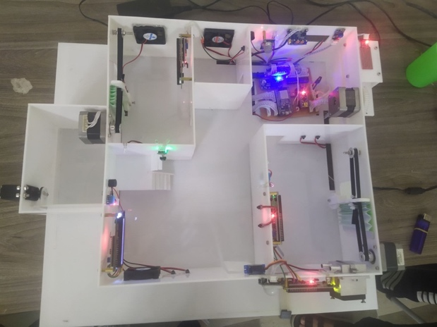

Figure 7. Realistic smart home model 1

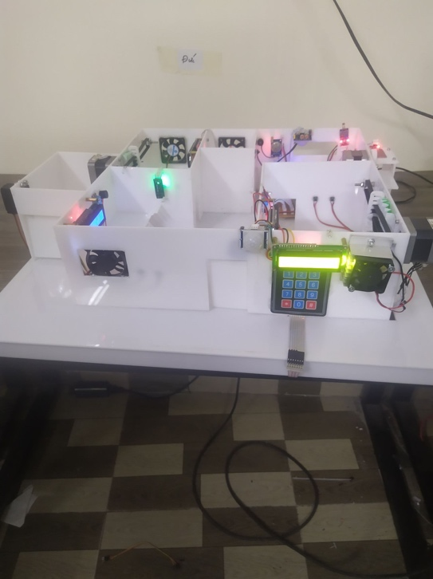

Figure 7. Realistic smart home model 2

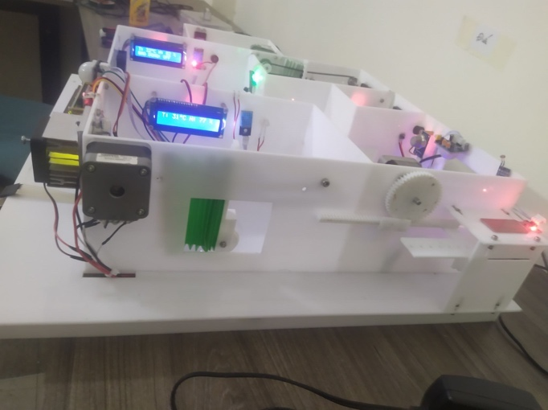

Figure 7. Realistic smart home model 3

Through running the experiment, there are some results:

* Using a smartphone with an internet connection to access the monitoring and control application, and to be able to control the device.
* The system runs relatively stable, meeting the initial requirements.

## **Monitoring and control interface**

The interface of the app is easy to use:

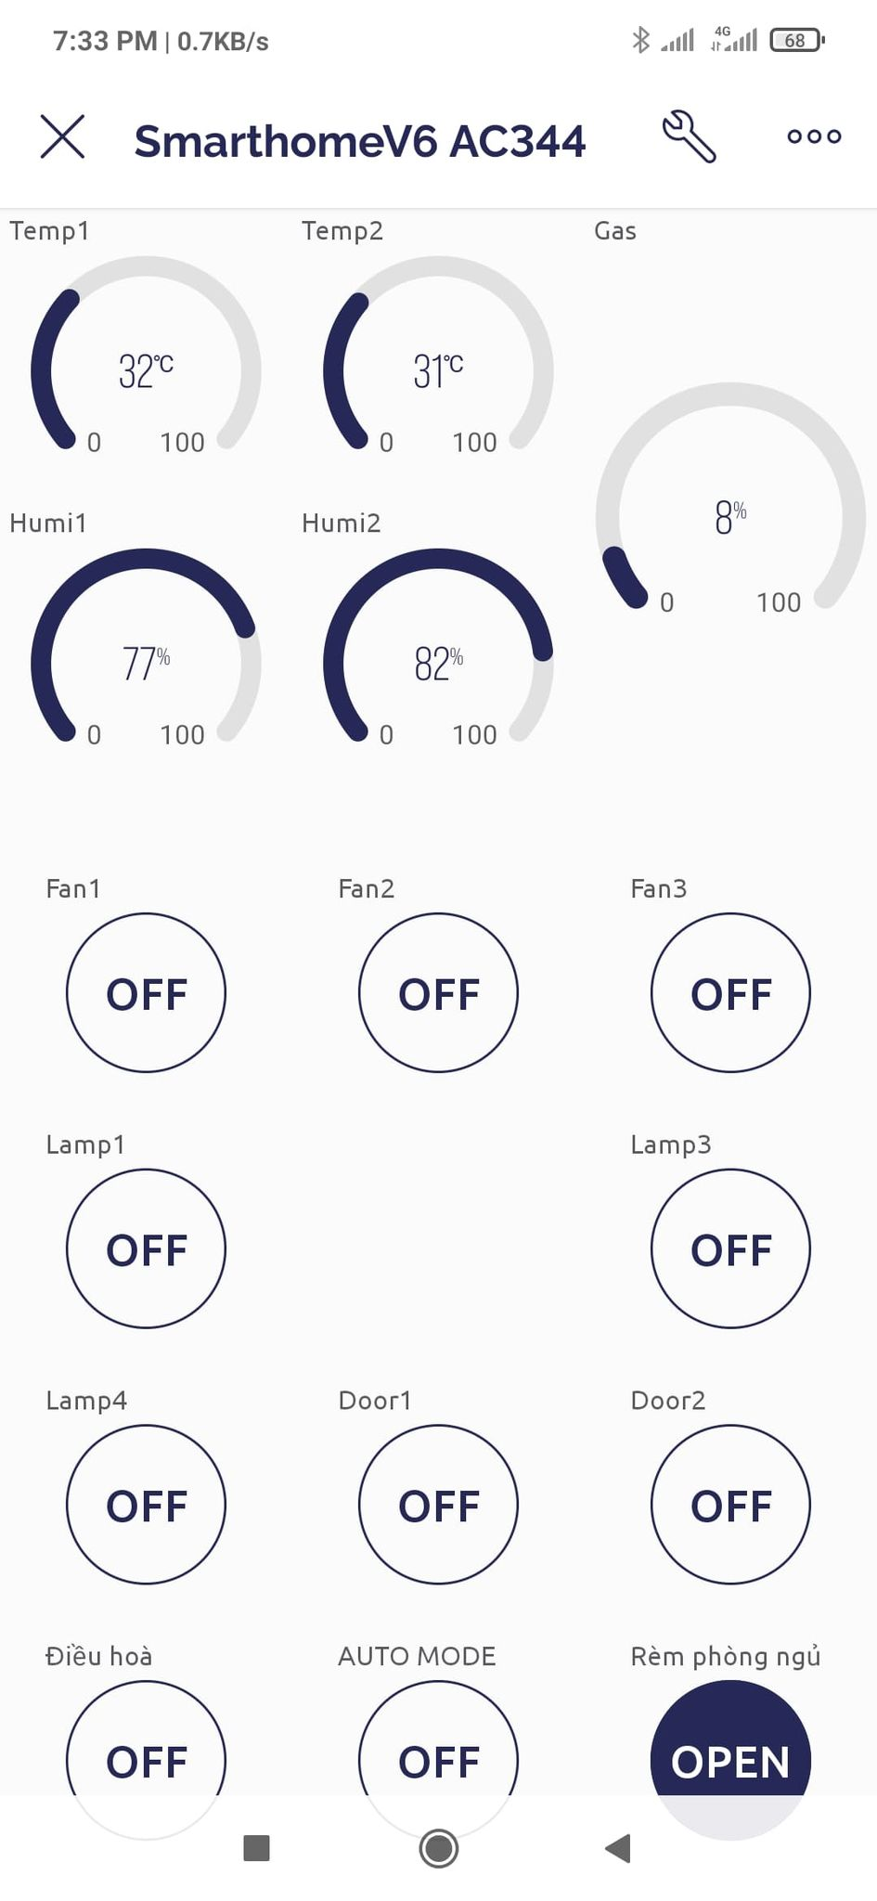

Figure 7. User interface of Blynk application

Structured console:

* Control and report the opening and closing status of doors.
* Monitor and control living room, playroom, and bedroom.
* Gas leak monitoring, house intrusion monitoring.
* Data will be sent to the app continuously.

## **Comment**

* There are some parts of the system that we were concerned about:
* The value of sensors is not 100% accuracy.
* The clothesline and curtains automation system has been stuck sometimes while activating because we haven’t found a correct way to handle the ratio between the distance of the curtain and clothesline with the rotation of the motor.
* The mechanical system is not yet rigid.
* The cooling system is not good enough so the Peltier cooling module can’t be activated more than 15m-20m.
* The control signal processing from the Blynk application to our system has been delayed sometimes.
* Some parts of the system have been controlled by the application yet.

# **CHAPTER 8: CONCLUSION**

## **1. Conclusion**

Since this is a fairly new topic, in the process of researching we have encountered certain difficulties. But with the passion and enthusiastic guidance of the teachers plus the effort to explore, the passion to discover new things has helped us achieve the following results:

* Overview of monitoring and control systems over the internet, and smart homes. At the same time, we also know the usage situation and development trends of Vietnam and other countries in the world.
* Successfully designed a smart home model.
* Learn the basis and meaning of controlling devices over the internet.
* Understand the working principle of the modules in the system and how to connect them.
* Run the experiment and evaluate the results.

Besides the obtained results, the model still has many technical limitations such as the ability to expand the number of monitoring and control variables, the occurrence of noise, the application interface response time is sometimes long.

**2. Future work**

The control and monitoring system via the internet has great significance in many aspects of life such as: security, national defense, livestock, health care, family, farming, etc. The mastery of this problem. there are still certain limitations, especially for a country that is developing science and technology like us. Through this topic, I want to use the knowledge learned during the student period to make access to technology and trends of the world.

Through this project, I would like to suggest some development directions for the system:

* Install surveillance camera system for the system.
* Improve the accuracy of the value of sensors
* Improve the accuracy of the actuators block
* Improve the garage system by allowing more than 1 vehicles stored in
* Improve the security of our living room by interacting magnetic card system or fingerprint system
* Improve door system working like the elevator door mechanism
* Improve the cooling system
* Improve the anti-theft system by image recognition
* Improve the mechanical system
* Application of monitoring and control systems in healthcare and education.
* Control smart devices through voice
* Build a management software on mobile devices, and a management software on the web, which can automatically notify users of adverse conditions.

# **References**

1. [Arduino.vn](http://arduino.vn/)
2. <https://startingelectronics.org/>
3. <http://vi.Wikipedia.org/>
4. Htt://google.com.vn/
5. <https://dientuviet.com/nha-thong-minh-su-dung-blynk-va-nodemcu/>
6. <https://nshopvn.com/blog/huong-dan-cai-dat-va-su-dung-blynk-new-2-0-tren-arduino-ide-voi-esp8266/>
7. <https://microcontrollerslab.com/74hc595-shift-register-interfacing-arduino/>
8. <https://dientutuonglai.com/tim-hieu-74hc595.html>
9. <https://nshopvn.com/product/nguon-adapter-12v-5a-2/>
10. <https://dientu360.com/nguon-adapter-24v-5a-loai-tot>
11. <https://arduinogetstarted.com/tutorials/arduino-button>
12. <https://arduinogetstarted.com/tutorials/arduino-keypad>
13. <https://www.adafruit.com/product/419>
14. <https://deviot.vn/blog/giao-tiep-i2c.05019305>
15. <https://dientutuonglai.com/chuan-giao-tiep-i2c-la-gi.html>
16. <https://www.watelectronics.com/lcd-16x2/>
17. <https://arduinokit.vn/giao-tiep-i2c-lcd-arduino/>
18. <https://banlinhkien.com/quat-tan-nhiet-5v-3x3x1cm-30105v-p6652368.html>
19. <https://nshopvn.com/product/module-2-relay-voi-opto-cach-ly-kich-h-l-12vdc/>
20. <https://www.electronicshub.org/what-is-relay-and-how-it-works/>
21. <https://banlinhkiendientu.vn/so-nong-lanh-la-gi/>
22. <https://nshopvn.com/product/cam-bien-mua/>
23. <https://medium.com/@kekreaditya/ir-infrared-obstacle-avoidance-sensor-with-arduino-714837ad9ef5>
24. <https://chotroihn.vn/module-cam-bien-anh-sang-tai-linh-kien-dien-tu-3m>
25. <https://nshopvn.com/product/cam-bien-vat-can-hong-ngoai/>
26. <https://batiea.com/bai-viet/cam-bien-hong-ngoai-la-gi-nguyen-ly-ung-dung-va-nhung-dieu-can-luu-y>
27. <https://hancatemc.com/dong-co-buoc-la-gi-cau-tao-cua-dong-co-step.html>
28. <https://nshopvn.com/product/cam-bien-than-nhiet-chuyen-dong-pir-hc-sr501/?gclid=CjwKCAjwrZOXBhACEiwA0EoRD7gXyQZK_3BGibikzzps7_4SZAr4Uv8ACAHehiGnWADJn4Hj0h2nHxoCWdgQAvD_BwE>
29. <https://blog.mecsu.vn/dong-co-servo-mg996r/>
30. <https://hshop.vn/products/dong-co-rc-servo-mg996-2>
31. <https://icdayroi.com/driver-a4988-stepper-motor>
32. <https://lastminuteengineers.com/a4988-stepper-motor-driver-arduino-tutorial/>
33. <https://deviot.vn/tutorials/esp32.66047996/tong-quan-ve-esp32.18482631>
34. https://esp32.vn/